[bibblio style="bib--row-3 bib--default bib--hover bib--white-label bib--font-arial bib--size-18" query_string_params="e30=" recommendation_type="optimised"]
CIVIC EDUCATION FIRST TERM NINTH WEEK BASIC 6
THEME:
BASIC 6
TOPIC: Ethnicity
An ethnicity, is a group of people with common or similar in common ancestry, language, history, society, culture or nation.
PERFORMANCE OBJECTIVES
By the end of the lesson, the pupils should have attained the following objectives (cognitive, affective and psychomotor) and be able to list and discuss some of the problems of Ethnic, State and Group Loyalty. [mediator_tech]
ENTRY BEHAVIOR
The pupils are required to already have learned patriotism and nationalism.
INSTRUCTIONAL MATERIALS
The teacher will teach the lesson with the aid of maps and charts.
METHOD OF TEACHING
- Explanation
- Exposition
- Discussion/interaction
- Questions and answers
REFERENCE MATERIALS
- Scheme of work
- 9 - Years Basic Education Curriculum
- Course book
- All Relevant Materials
- Online Materials
[bibblio style="bib--row-3 bib--default bib--hover bib--white-label bib--font-arial bib--size-18" query_string_params="e30=" recommendation_type="optimised"]
CONTENT OF THE LESSON
ETHNICITY CONFLICT
Ethnicity or Communal conflicts in Nigeria can be divided into two broad categories:
- Ethnic conflicts - These are conflicts tribe and religious conflicts.
- Herder and farmer conflicts - These are conflicts between herdsman and farmers.[mediator_tech]
MAP OF NIGERIAN'S DIVERSITY
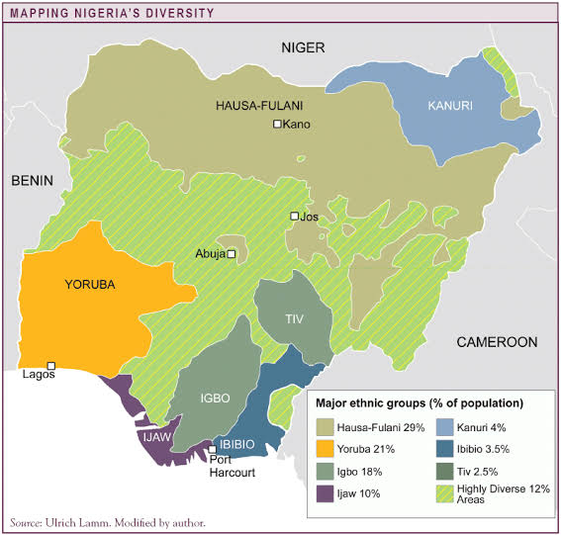
[bibblio style="bib--row-3 bib--default bib--hover bib--white-label bib--font-arial bib--size-18" query_string_params="e30=" recommendation_type="optimised"]
PROBLEMS OF ETHNIC, STATE AND GROUP LOYALTY
The greatest problems of ethnic, state and group loyalty in Nigeria are:
- Ethics crisis
- Political instability
- Election malpractice
- Inflation of census figures
- Unreliable census figures makes planning difficult[mediator_tech]
SOLUTIONS TO ETHNIC, STATE AND GROUP LOYALTY
The solutions to avert future occurrence includes:
- the development of all parts of the country, and practice of justice and equity in the land.
- Conflicts do not do us any good so let us shun them and fight for peace and progress instead.
- Finally, the use of ethnic, state or group loyalty and religious sentiments to cause division and conflicts will lose its appeal when the constitution is amended, and government starts fiscal federalism and devolution of power to the states and local government councils.
PRESENTATION
- To deliver the lesson, the teacher adopts the following steps:
- To introduce the lesson, the teacher revises the previous lesson. Based on this, he/she asks the pupils some questions;
- Explains the problem of ethnic state and group loyalty;
- Guides the pupils to groups on the map of Nigeria;
- Pupil’s Activities - Locate the various ethnic groups on the map of Nigeria.
CONCLUSION
To conclude the lesson for the week, the teacher revises the entire lesson and links it to the following week’s lesson - National symbols.
LESSON EVALUATION
Pupils to list three problem facing ethnic groups and discuss them.

