COMPUTER STUDIES FIRST TERM FIRST WEEK 7 BASIC 6
THEME: INFORMATION TECHNOLOGY - BASIC COMPUTER OPERATIONS
TOPIC: Learning Word Processing with the Computer
A Word Processing is an application that allows you type, saving, edit and print text using a word processing application package.
PERFORMANCE OBJECTIVES
- By the end of the lesson, the pupils should have attained the following objectives (cognitive, affective and psychomotor) and be able to:[mediator_tech]
- identify Word processing Software;
- mention some of the uses of Word Processing software.
ENTRY BEHAVIOR
The pupils are required to already have learned to advantages and disadvantages of computers network.
INSTRUCTIONAL MATERIALS
The teacher will teach the lesson with the aid of a functional computer system.
METHOD OF TEACHING
- Explanation
- Discussion
- Demonstration
- Questions and answers
REFERENCE MATERIALS
- Scheme of Work
- 9 - Years Basic Education Curriculum
- Foundation Computer Studies Book 6
- Computer Studies for Primary School Book 6[mediator_tech]
- All Relevant Material
- Online Information
Related posts - computer network, description of local area network and large area network, topology and types, sketches and describe network topology, advantages and disadvantages of computer network. Scheme of work - first term - second term - third term.
CONTENT OF THE LESSON
WORD PROCESSING SOFTWARE
A Word Processing Software is an application that allows you to type in, edit, format, save, and print text.
These are a few examples:
- Microsoft Word
- WordPerfect
- WordStar
- Corel Word Perfect
MICROSOFT WORD (Ms Word) - Stating Ms Word
- From the desktop, click the start button.
- Among the list of programs, click Microsoft Office Word. If it is not included among the list, click all Programs or search for Microsoft Office Word.
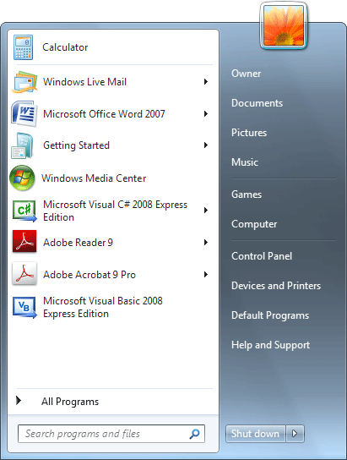
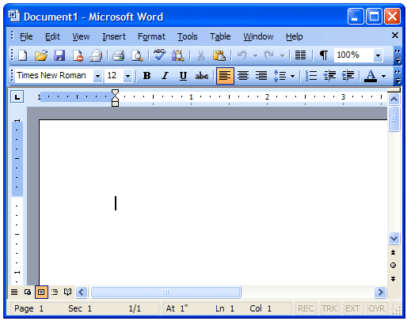

The user can start typing in the above page or edit the existing stored document in files in the computer system. [mediator_tech]
USE OF THE WORD PROCESSING SOFTWARE
- Creating, editing, saving and printing documents.
- Copying, pasting, moving and deleting text within a document.
- Formatting text, such as font type, bolding, underlining or italicizing.
- Creating and editing tables.
- Inserting elements from other software, such as illustrations or photographs.
- Correcting spelling and grammar.
PRESENTATION
- To deliver the lesson, the teacher adopts the following steps:
- To introduce the lesson, the teacher revises the previous lesson. Based on this, he/she asks the pupils some questions;
- Explains what Word Processing software is;
- Pupil’s Activities - Explain Word Processing Software.
- Mentions some uses of the Word Processing software;[mediator_tech]
- Pupil’s Activities - Listen, learn and demonstrate what Word Processing software is and what it is used for.
- Guides the pupils to start Ms Word;
- Pupil’s Activities - Starts Ms Word.
CONCLUSION
- To conclude the lesson for the week, the teacher revises the entire lesson and links it to the following week’s lesson - word processor skills.
LESSON EVALUATION
Pupils to:
- identify Word processing Software;
- mention at least three uses of Word Processing software.
[mediator_tech][mediator_tech]

