PHYSICAL AND HEALTH EDUCATION
FIRST TERM
ELEVENTH WEEK
BASIC 5
THEME: GAMES AND SPORTS
TOPIC: Volleyball
Volleyball is a team sport in which two teams of six players are separated by a net. To win the game you must score more points than your opponents. [mediator_tech] The best of 3 or 5 sets are generally played and the winners will be the first team to reach the required number of sets.
[bibblio style="bib--default bib--hover bib--white-label bib--font-arial bib--size-18 bib--grd-6" query_string_params="e30=" recommendation_type="optimised"]
PERFORMANCE OBJECTIVES
By the end of the lesson, the pupils should have attained the following objectives (cognitive, affective and psychomotor) and be able to:
- name the officials in the volleyball and their duties;
- mention the rules in volleyball;
- apply the rules in game situation.
ENTRY BEHAVIOR
The pupils are required to already have learned in basic 5:
- history of volleyball in Nigeria;
- Facilities and equipment used in volleyball; [mediator_tech]
- dimension of volleyball court.
INSTRUCTIONAL MATERIALS
The teacher will teach the lesson with the aid of:
- Volleyball balls
- Whistle
- Textbook
- Nets
- Volleyball court
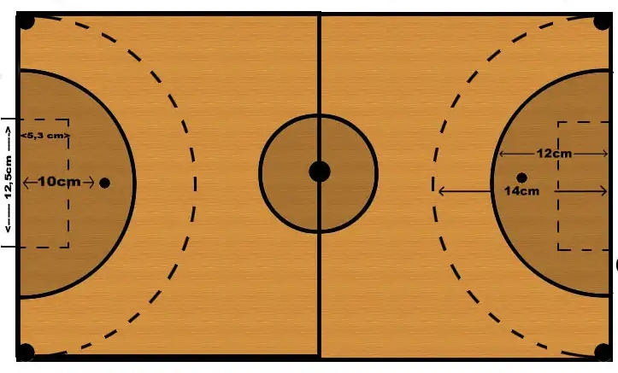
METHOD OF TEACHING
- Demonstration
- Explanation
- Discussion
- Questions and Answers
REFERENCE MATERIALS
- Scheme of Work
- 9 - Years Basic Education Curriculum
- Theory of Sport Practice by P. O. Omidran and P. O. Okuneye;
- Compendium Physical and Health Education for basic 6;
- Rules of Sport
- Living Strong
- All Relevant Materials
[mediator_tech]
[bibblio style="bib--default bib--hover bib--white-label bib--font-arial bib--size-18 bib--grd-6" query_string_params="e30=" recommendation_type="optimised"]
CONTENT OF THE LESSON
NATURE OF PLAYING VOLLEYBALL
The object of volleyball is to hit the volleyball over the net (by only using your hands) running through the centre of the court whilst trying to get it to bounce in your opponents half.
The opposing team have to try and prevent the ball from bouncing before returning the ball. Games are played out in best of 3 or 5 sets and the team with most sets at the end of the game wins.
It has been a part of the official program of the Summer Olympic Games since 1964. [mediator_tech]
VOLLEYBALL OFFICIALS AND THEIR DUTIES
As in most sporting competitions, volleyball employs referees in order to control the flow of the game and enforce the rules.
The volleyball referee team includes:
- The first referee - The first referee stands on the referee stand and controls the play of the entire game. Whatever issues arise during the game, the first referee determines the call and the has the final say.
- The second referee - The second referee works to assist the first referee throughout the game. The second referee is in charge of all substitutions, timeouts and the actions of the scores table.
- The scorer - The official scorer keeps track of the score throughout the volleyball game.
- The two line judges - At least two line judges monitor each game. [mediator_tech]
POSITION OF PLAYERS
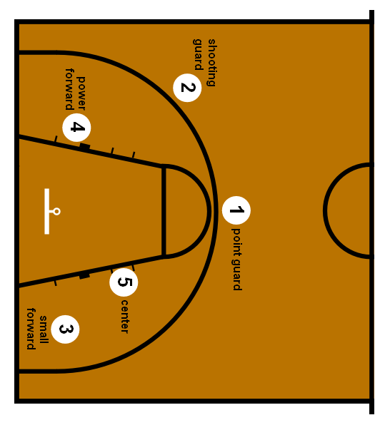
VOLLEYBALL OFFICIATING RULES
- Each team consist of 6 players and 6 substitutes.
- Each team can hit the ball up to three times before the ball must be returned.
- The defensive team can then try and block or return the ball again hitting it a maximum of three times.
- Games are played up to 25 points and must be won by 2 clear points.
- Violations will be called for the following:
- Stepping over the base line when serving the ball.
- Ball hits the net and fails to get over the net. [mediator_tech]
- Players are not allowed to carry, palm or run with the ball.
- Players must not touch the net with any part of the body. If the net is said to have hit them rather than vice-versa, then this is ok.
- The ball cannot travel under the net.
- Players cannot reach over the net and hit the ball.
PRESENTATION
- To deliver the lesson, the teacher adopts the following steps:
- To introduce the lesson, the teacher revises the previous lesson. Based on this, he/she asks the pupils some questions;
- Explains playing according to the rules;
- Describe the roles of the officials;
- Pupil’s Activities - Listen to the teacher's explanations; Play volleyball;
- Applying the rules and regulations.
- Note taking. [mediator_tech]
CONCLUSION
To conclude the lesson for the week, the teacher revises the entire lesson and links it to the following week’s lesson -
LESSON EVALUATION
Pupils to:
- list the officials in volleyball;
- states the rules and regulations;
- apply the rules during game situation.

