LESSON DEVELOPMENT TWO

Application of Pythagoras' rule

STAGE/TIME | TEACHER’S ACTIVITIES | LEARNER'S ACTIVITIES – MIND/HANDS ON | LEARNING POINTS
Step 1  Introduction  (5 minutes) | Based on their knowledge, the teacher asks the following questions - What is Pythagoras rule? | Pythagoras rule means the sum of the squares of the other two sides is equal to the square of the longest length. | Previous knowledge confirmed.
Step 2  Development  (5 minutes) | 1. Groups the pupils into four groups – A, B, C, and D.  2. Guide the pupils to choose a leader and secretary for your group.  3. Gives each group learning materials. | 1. Belong to a group.  2. Choose their leader and secretary.  3. Received learning materials for their group. | Pupil’s group, leader and secretary confirmed.
Step 3  Development  (10 minutes) | Guides the pupils to use Pythagoras rule to calculate the unknown side.  a^2 + b^2 = c^2 | 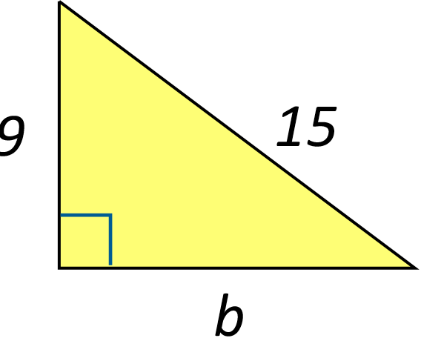  a^2 + b^2 = c^2  9^2 + b^2 = 15^2  81 + b^2 = 225  b^2 = 225 – 81 = 144  b = √144 = √(12 x 12)  b = 12 | Application of Pythagoras rule
Step 4  Development  (10 minutes) | Guides the pupils to use Pythagoras rule to calculate the unknown side.  a^2 + b^2 = c^2 | 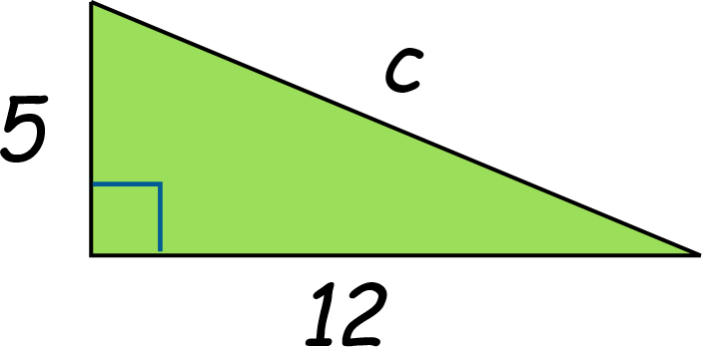  a^2 + b^2 = c^2  5^2 + 12^2 = c^2  25 + 144 = c^2  169 = c^2  c = √169 = 13 | Application of Pythagoras rule
Step 5  (10 minutes) | ASSIGNMENT  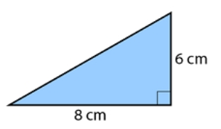  Calculate the unknown sides  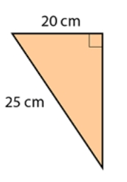  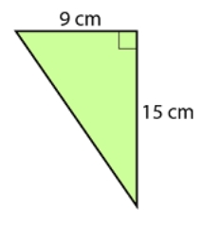  CONCLUSION  To conclude the lesson for the week, the teacher revises (through questions and answers) the entire lesson and links it to the next lesson. | Listen, ask and answer questions. | Assignment and Conclusion

