LESSON DEVELOPMENT TWO

Pythagoras' rule

STAGE/TIME | TEACHER’S ACTIVITIES | LEARNER'S ACTIVITIES – MIND/HANDS ON | LEARNING POINTS
Step 1  Introduction  (5 minutes) | Based on their knowledge, the teacher asks the following questions –  - Describe right angle triangle.  - What is the longest side of right angle triangle called? | - Right angles triangle has one of its angle is at 90°.  - It is called hypotenuse while other two sides are opposite and adjacent. | Previous knowledge confirmed.
Step 2  Development  (5 minutes) | 1. Groups the pupils into four groups – A, B, C, and D.  2. Guide the pupils to choose a leader and secretary for your group.  3. Gives each group learning materials. | 1. Belong to a group.  2. Choose their leader and secretary.  3. Received learning materials for their group. | Pupil’s group, leader and secretary confirmed.
Step 3  Development  - minutes) | Guides pupils to draw a right-angled triangle with side 3cm, 4cm and 5cm. | 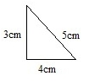
Step 4  Development  (20 minutes) | Guides pupils to:  - Name all sides a, b and c.  - Square each of the side.  - Add square a and b, a and c, b and c.  - Compare the results square of a, b and c.  Use their comparison to lead them to Pythagoras rule and its meaning.  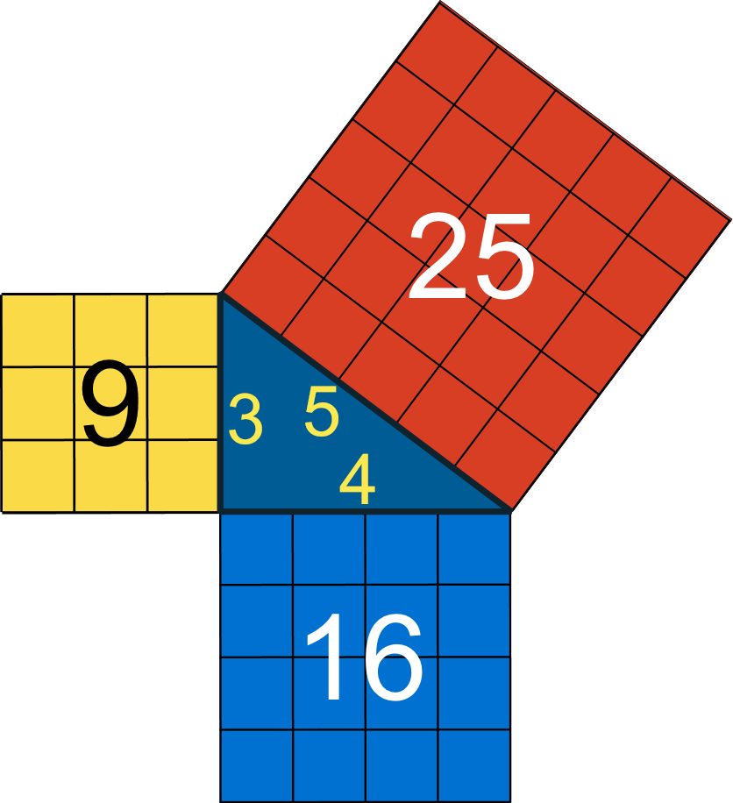 | 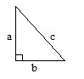  That’s, a = 3cm, b = 4 cm and c = 5cm.  2. a^2 = 9, b = 4^2 = 16 and c^2 = 25.  3. a^2 + b^2 = 9 + 16 = 25, a^2 + c^2 = 9 + 25 = 34, b^2 + c^2 = 16 + 25 = 41.  4. a^2 + b^2 = c^2 that’s 9 + 16 = 25  Pythagoras rule means the sum of the squares of the other two sides is equal to the square of the longest length. | Meaning of Pythagoras rule
Step 5  (5 minutes) | CONCLUSION  To conclude the lesson for the week, the teacher revises (through questions and answers) the entire lesson and links it to the next lesson. | Listen, ask and answer questions. | Conclusion

