LESSON DEVELOPMENT ONE

PARTS OF FLOWER

STAGE/TIME | TEACHER’S ACTIVITIES | LEARNER'S ACTIVITIES – MIND/HANDS ON | LEARNING POINTS
Step 1  Introduction  (5 minutes) | Guides pupils to identify flowers and different types of flower on the chart.  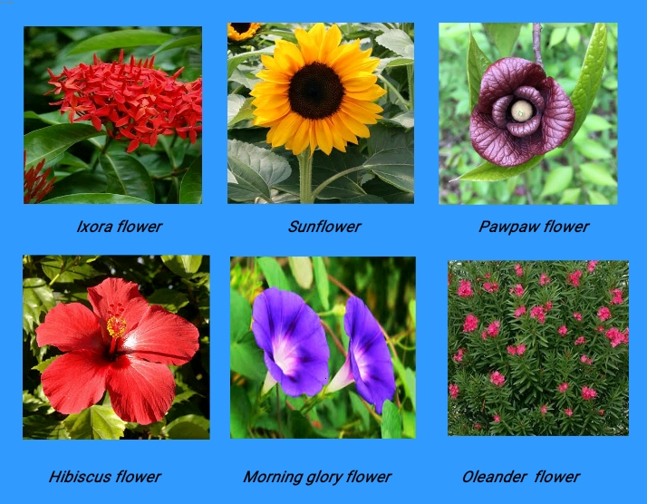 | Pupils identify the following flowers:  1. Hibiscus flower  2. Sunflower  3. Pawpaw flower  4. Morning glory flower  5. Oleander flower  6. Ixora flower | Previous knowledge
Step 2  Development  (5 minutes)  Grouping | 1. Groups the pupils into four groups – A, B, C, and D.  2. Guide the pupils to choose a leader and secretary for your group.  3. Gives each group learning materials. | 1. Belong to a group.  2. Choose their leader and secretary.  3. Received learning materials for their group. | Pupil’s group, leader and secretary confirmed.
Step 3  Development  (5 minutes) | Guides pupils to identify real flowers by name from the flowers on chart. | 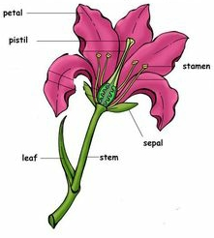  As mentioned in step 1. | Names of different flowers (real) are identified.
Step 4  Development  (15 minutes) | 1. Shows and guides pupils to identify Teacher anther and stigma of the flower.  4. State uses of flower. | 1. Pupils observe and identify anthers and stigma.  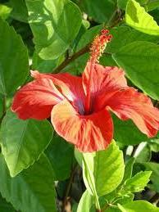  2. Uses of flower  Flower is used to:  a. decoration.  b. beautify the house, office, school and environment.  c. mark boundary of land.  d. beautify our table. | 1. Parts of hibiscus flower identified.  2. Anther and stigma.  3. Uses of flower
Step 5  Conclusion  (10 minutes) | To conclude the lesson, the teacher revises the entire lesson and links it to the next lesson and asks the key questions.  Asks pupils to draw and label parts of hibiscus flower. | Pupils listen, ask and answer questions. | Conclusion

