LESSON DEVELOPMENT TWO

POLLINATION OF FLOWERS

STAGE/TIME | TEACHER’S ACTIVITIES | LEARNER'S ACTIVITIES – MIND/HANDS ON | LEARNING POINTS
Step 1  Introduction  (5 minutes) | 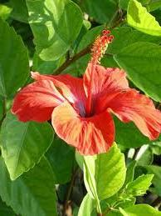  Identify anthers and stigma parts of flower. | Pupils identify anthers and stigma of flower. | Previous knowledge
Step 2  Development  (5 minutes)  Grouping | 1. Groups the pupils into four groups – A, B, C, and D.  2. Guide the pupils to choose a leader and secretary for your group.  3. Gives each group learning materials. | 1. Belong to a group.  2. Choose their leader and secretary.  3. Received learning materials for their group. | Pupil’s group, leader and secretary confirmed.
Step 3  Development  (5 minutes) | 1.. Guides pupils to touch the anthers and stigma and asks what they feel.  2. Lets pupils to know that anthers is the male part of a flower.  3. While stigma is the female part of a flower. | Pupils observe and identify anthers which contain yellow dust and stigma which has a sticky section. | Anthers and stigma as male and female reproductive parts of flower.
Step 4  Development  (15 minutes) | 1. Shows and asks pupils what butterfly is doing on flowers.  2. Lets pupils to know that as the butterfly is sucking, it transfers pollen grains to the stigma.  3. This process is called pollination of flowers.  4. Lets pupils to know that some flowers does not attract butterfly or insects, pollination takes place by wind. | 1. Pupils observe and discuss among themselves and conclude that the butterfly is sucking sweet things in the flowers.  2. Pupils understand the concepts of pollination.  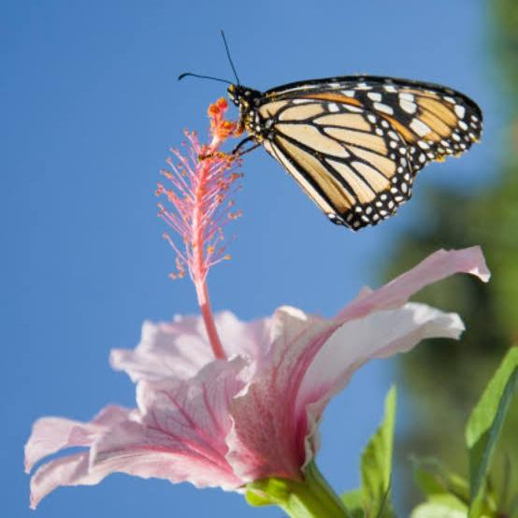 | Concept of pollination by insects or wind.
Step 5  Conclusion  (10 minutes) | Asks questions to evaluate the achievement of the objective.  1. What is pollination?  2. How does pollination occur?  3. What are the agents of pollination? | Learners review and summarize what they have done and learnt during the lesson.  1. Pollination is a process were by the anther is transfer to stigma of the flower.  2. Pollination occurs through activities of insects or wind on the flower.  3. The agents of pollination are insects, butterfly, wind etc. | Meaning of pollination and agents of pollination.

