LESSON DEVELOPMENT TWO

AREA OF TRAPEZIUM

STAGE/TIME | TEACHER’S ACTIVITIES | LEARNER'S ACTIVITIES – MIND/HANDS ON | LEARNING POINTS
Step 1  Introduction  (5 minutes) | Asks –  1. What is trapezium?  2. Draw trapezium.  3. Identify the parallel and perpendicular lines. | 1. A trapezium is a quadrilateral (four sided shapes) that has only one pair of parallel sides.  2. Pupils draw trapezium.  3. Identify parallel and perpendicular (height) lines. | Previous knowledge confirmed.
Step 2  Development  (5 minutes)  Grouping | 1. Groups the pupils into four groups – A, B, C, and D.  2. Guide the pupils to choose a leader and secretary for your group.  3. Gives each group learning materials – cardboards, pencils, ruler and scissors. | 1. Belong to a group.  2. Choose their leader and secretary.  3. Received learning materials for their group. | Pupil’s group, leader and secretary confirmed.
Step 3  Development  (10 minutes) | Guides pupils to identify the bases and the height of trapezium.  Lets them name the bases as base 1 and base 2.  Guides them to find the area trapezium  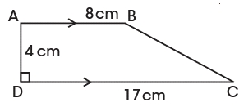  Guided Instructions  1. Add the two bases together.  2. Multiple by the height.  3. Divide the result by 2.  Then, introduce the formula for finding the area of trapezium = ½ (a + b) h. | Pupil’s working  Base 1 = a = 8 cm  Bases 2 = b = 17 cm  Height = 4 cm  Base = 8 cm + 17 cm = 25 cm  Base x height = 25 cm x 4 cm = 100 cm^2  Area = (100 cm^2) /2 = 50 cm^2  Area of trapezium  = ½ x base x height,  where base = a + b, Height = h  = ½ (a + b) h | Area of trapezium
Step 4  Development  (5 minutes) | Leads pupils to apply the formula for area of trapezium.  Find the area of trapezium  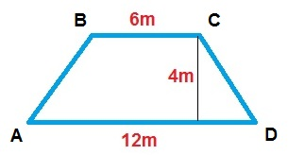 | Area of trapezium = = ½ (a + b) h  a = 6cm, b = 12 cm and h = 4cm  = ½ x (6 cm + 12 cm) x 4 cm  = ½ x 18 cm x 4 cm  = ½ x 72 cm^2 = 36 cm^2 | Trapezium and its properties.
Step 4  Conclusion  (15 minutes) | To conclude the lesson, teacher give class work.  Find the are of  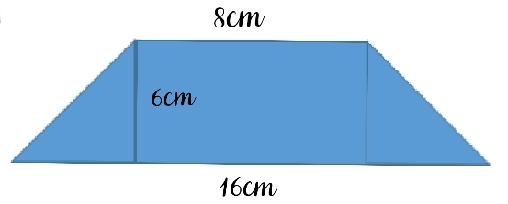  1.  2.  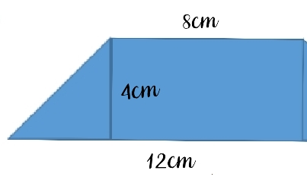 | Classwork and correction. | Conclusion and evaluation.

