LESSON DEVELOPMENT THREE

VOLUME OF SPHERE

STAGE/TIME | TEACHER’S ACTIVITIES | LEARNER'S ACTIVITIES – MIND/HANDS ON | LEARNING POINTS
Step 1  Introduction  (5 minutes) | Lets the pupils identify and describe a ball, oranges and globe (if available).  Lets them know that objects like a ball, an orange, etc. are refer as sphere. | Pupils identify and describe ball and orange as round surface.  Pupils understand a ball and an orange as a sphere. | Linking Previous knowledge to the lesson.
Step 2  Development  (5 minutes)  Grouping | 1. Groups the pupils into four groups – A, B, C, and D.  2. Guide the pupils to choose a leader and secretary for your group.  3. Gives each group learning materials – tin of milk, tomato and milo. | 1. Belong to a group.  2. Choose their leader and secretary.  3. Received learning materials for their group. | Pupil’s group, leader and secretary confirmed.
Step 3  Development  (5 minutes) | Introduces the formula for the volume of sphere –  A sphere with radius r has volume 4/3 π r^3  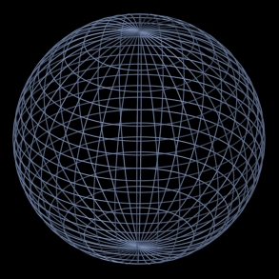 | Pupils study and interprete the volume as  V = 4/3 x 22/7 x r x r x r | Formula for the volume of sphere
Step 4  Development  (5 minutes) | Guides pupils find the volume of –  Calculate the volume of each of these spheres.  1. Radius 21 cm  2. Radius 3 cm | V = 4/3 π r^3  Solution 1 – r = 21 cm  V = 4/3 x 22/7 x 21 cm x 21 cm x 21 cm  = 4 X 22 x 21 cm x 21 cm x 1 cm  = 38808‬ cm^3  Solution 2 - r = 3 cm  V = 4/3 x 22/ 7 x 3 cm x 3 cm x 3 cm  = 4 X 22/ 7 x 3 cm x 3 cm x 1 cm  = 113.14 cm ^3 | Working examples
Step 5  Development  (15 minutes) | Guides pupils to apply the formula for volume of sphere to find –  1. Radius 6 cm  2. Radius 10 cm  3. Diameter 14 cm | Pupils working | Working Exercise
Step 6  Conclusion/Evaluation  (5 minutes) | To conclude the lesson, the teacher revises the entire lesson and links it to the next lesson, and asks the key questions. | Listen, ask and answer questions | Conclusion

