LESSON DEVELOPMENT ONE

VOLUME OF TRIANGULAR PRISM

STAGE/TIME | TEACHER’S ACTIVITIES | LEARNER'S ACTIVITIES – MIND/HANDS ON | LEARNING POINTS
Step 1  Introduction  (5 minutes) | Guides pupils to identify the characteristics of rectangular prism.  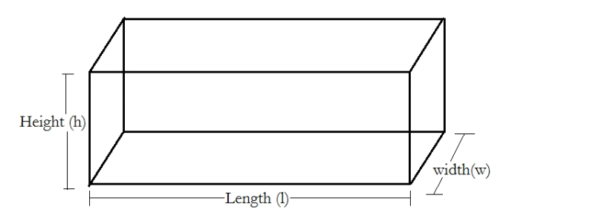  Note – generally known as box or cartoon by the pupils.  Asks the following key questions –  1. How many faces does it has?  2. How many vertices (corners) does it has?  3. Give examples of shape that are rectangular prism.  Leads them to identify length, breadth (width) and height.  Remarks – triangular prism is a 3 dimensional shape. | Characteristics of triangular prism –  1. It has 6 sides (faces).  2. It has 8 vertices (corners).  3. Textbook, bread, cartoon (box), etc. | Linking Previous knowledge to the lesson.
Step 2  Development  (5 minutes)  Grouping | 1. Groups the pupils into four groups – A, B, C, and D.  2. Guide the pupils to choose a leader and secretary for your group.  3. Gives each group learning materials – cuboid or bread. | 1. Belong to a group.  2. Choose their leader and secretary.  3. Received learning materials for their group. | Pupil’s group, leader and secretary confirmed.
Step 3  Development  (5 minutes) | Guides pupils to recognize the volume of triangular prism as Length x Breadth x Height.  That’s, V = L x B x H | Pupils identify and recognize the volume of triangular prism. | Volume of rectangular prism.
Step 4  Development  (10 minutes) | In a rectangular prism, the uniform cross section is a rectangle.  Guides pupils to slice along the diagonal, to formed two triangular prisms. | 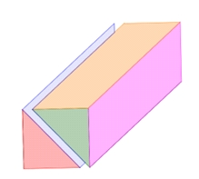  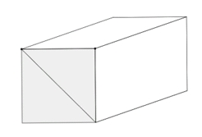  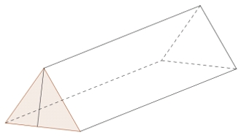 | Forming triangular prism
Step 5  Development  (5 minutes) | Lets pupils to observe and compare rectangular prism with the triangular prism.  Asks what’s their observations? | Pupils observe and discover that two triangular prisms form a triangular prism. | Comparison of rectangular and triangular prisms.
Step 6  Development  (5 minutes) | Leads and guides pupils the pupils to identify –  1. Base area and height or  2. Base length, base height and height | Base area is the area of triangle,  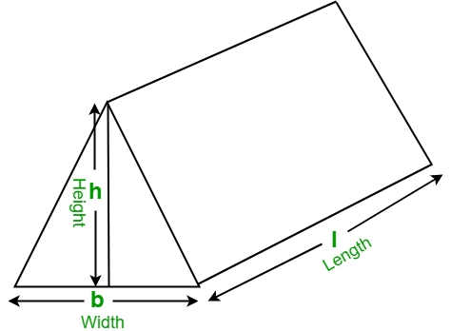  i.e. ½ b x h x H | Formula for finding the volume of triangular prism
Step 6  Conclusion/Evaluation  (10 minutes)  To conclude the lesson, the teacher revises the entire lesson and links it to the next lesson, and asks the key questions. | Guides pupils to find the volume of –  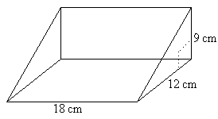  Home Work  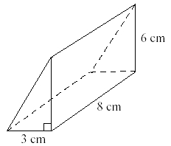  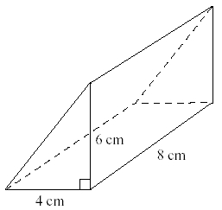  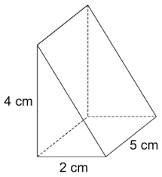 | Pupils working –  Given, b = 18 cm, h = 12 cm and H = 9 cm  V = ½ x b x h x H = ½ x (18 x 12 x 9) cm^3  = (9 x 12 x 9) cm^3 = 972 cm^3  Taken down home work | Conclusion, Example and Home work

