LESSON DEVELOPMENT THREE

WATER CYCLE

STAGE/TIME | TEACHER’S ACTIVITIES | LEARNER'S ACTIVITIES – MIND/HANDS ON | LEARNING POINTS
Step 1  Introduction  (5 minutes) | Guides pupils to recall and describe the process of rain formation. | When the rain fall, the ground gets wet. After the sun rises up (boiling water), the water turn into water vapour (steam) and rises into the sky (cold metal).  The water vapour form the clouds in the sky. When the clouds become larger, it falls as rain (dropping water). | Linking the Previous knowledge to the new lesson
Step 2  Development  (5 minutes)  Grouping | 1. Groups the pupils into four groups – A, B, C, and D.  2. Guide the pupils to choose a leader and secretary for your group.  3. Gives each group learning materials. – chart of water in nature and cardboards, rulers, pencils, etc. | 1. Belong to a group.  2. Choose their leader and secretary.  3. Received learning materials for their group. | Pupil’s group, leader and secretary confirmed.
Step 3  Development  (10 minutes) | 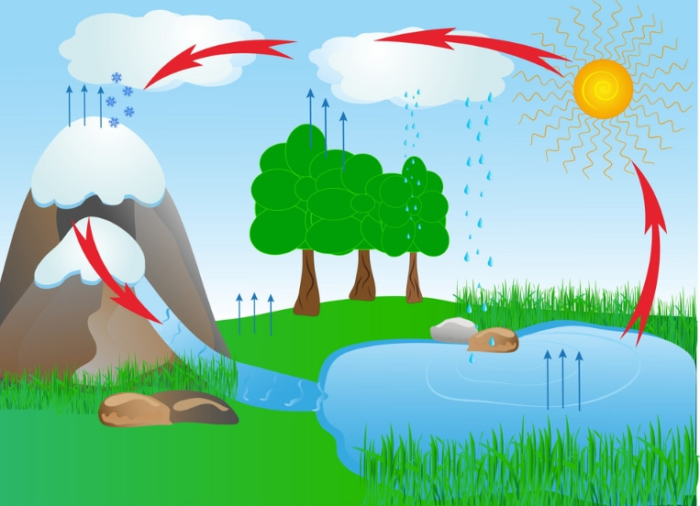  Guides pupils to describe the chart. | Four red arrows formed a circle.  There is a sun and arrows from the river, ground, mountain and trees going up the sky.  There is water dropping like rain from the sky. | Describing water cycle
Step 4  Development  (10 minutes) | Guides pupils to draw a water cycle.  Sun  Water vapour Rainfall  The earth | 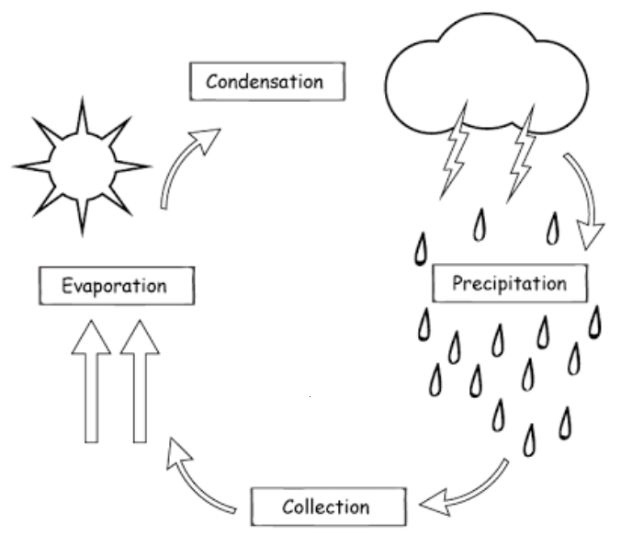 | Drawing of water cycle
Step 5  Conclusion  (10 minutes)  To conclude the lesson, the teacher revises the entire lesson and links it to the next lesson. | What is water cycle? | Water cycle is the process whereby the water that fall as rain evaporate in the sky in form of clouds and fall back as rain. | Conclusion

