LESSON DEVELOPMENT THREE

AREA OF RIGHT – ANGLE TRIANGLE

STAGE/TIME | TEACHER’S ACTIVITIES | LEARNER'S ACTIVITIES – MIND/HANDS ON | LEARNING POINTS
Step 1  Introduction  (5 minutes) | Guides pupils to identify and describe areas of triangle in this rectangle –  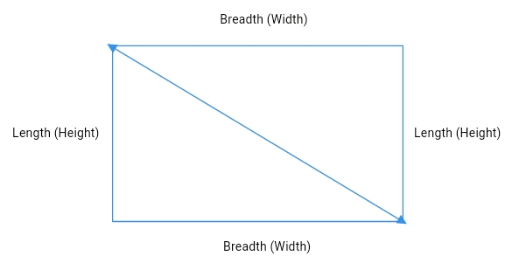 | This is a rectangle. It is made up of two right – angle triangle. The area of rectangle is length x breadth.  Area of right – angle triangle = length x breadth ÷ 2  That’s ½ base x height | Previous knowledge
Step 2  Development  (5 minutes)  Grouping | 1. Groups the pupils into four groups – A, B, C, and D.  2. Guide the pupils to choose a leader and secretary for your group.  3. Gives each group learning materials – | 1. Belong to a group.  2. Choose their leader and secretary.  3. Received learning materials for their group. | Pupil’s group, leader and secretary confirmed.
Step 3  Development  (10 minutes) | Lets the pupils find the areas of the following right – angle triangles –  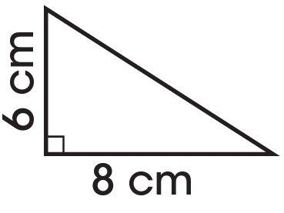 | Area of right – angle triangle = ½ b x h  1. A = ½ x 6 cm x 8 cm  = 3 cm x 8 cm  = 24 cm^2  2. A = ½ x 10 cm x 12 cm  = 5 cm x 12 cm  = 60 cm^2 | Area of triangle
Step 4  Development  (10 minutes) | 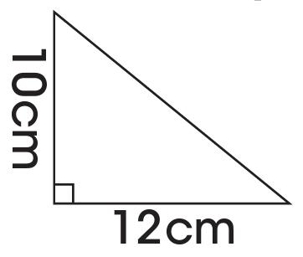 |  | Concept of right – angle triangle
Step 5  Development  (10 minutes) | Assignment  1. A rectangular classroom is 100 m long and 20 m wide. Find the area of right – angle triangles.  2. A square room has a side of length 18 m. Find the area of right – angle triangles. | Pupils take down work to do at home | Assignment
Step 6  Conclusion/Evaluation  (5 minutes) | To conclude the lesson, the teacher revises the entire lesson and links it to the next lesson, and asks the key questions. | Pupils listen, ask and answer questions. | Conclusion

