LESSON DEVELOPMENT TWO

CUTTING OF SQUARE AND RECTANGLE

STAGE/TIME | TEACHER’S ACTIVITIES | LEARNER'S ACTIVITIES – MIND/HANDS ON | LEARNING POINTS
Step 1  Introduction  (5 minutes) | Guides the pupils through their work to do at home –  1. What is the square between a square and a rectangle?  2. Get a cartoon and cut out one of its faces.  3. What shape does it presents?  4. Cut the Shape into two from corner to another.  What shape does it presents? | 1. Square has 4 equal sides while rectangle has its 2 opposite sides equal.  2. Cut out a square and rectangle.  3. Square or rectangle  4. It is a triangle | Previous knowledge
Step 2  Development  (5 minutes)  Grouping | 1. Groups the pupils into four groups – A, B, C, and D.  2. Guide the pupils to choose a leader and secretary for your group.  3. Gives each group learning materials – shapes of square and rectangle. | 1. Belong to a group.  2. Choose their leader and secretary.  3. Received learning materials for their group. | Pupil’s group, leader and secretary confirmed.
Step 3  Development  (5 minutes) | Lets the pupils find the are of this square and rectangle –  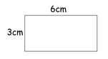 | Area of rectangle = Length X Breadth  Length = 3 cm, Breadth = 6 cm  A = 3 cm x 6 cm = 18 cm^2 | Area of rectangle
Step 4  Development  (10 minutes) | Reviews the pupils activities –  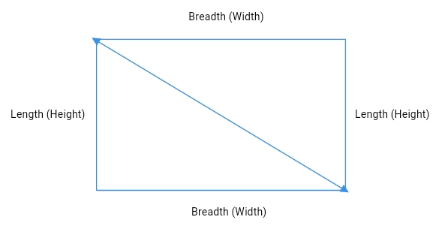  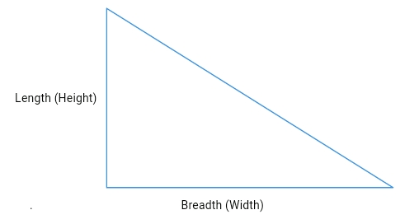  Lets pupils know that when a rectangle or square is cut through the diagonal, they get triangle.  Lets them divide the result of area of rectangle in step 3 by 2. | The Pupils understand the concept of triangle from cutting the rectangle or square through the diagonal.  Area of rectangle = 18 cm^2  Area of triangle = 18/2 cm^2  = 9 cm^2 | Concept of right – angle triangle
Step 5  Development  (10 minutes) | Leads pupils to arrive to area of triangle = ½ base x height, where base is the width or breadth and height is the length. | The pupils under the area of right – angle triangle is ½ base x height. | Area of triangle
Step 6  Conclusion/Evaluation  (5 minutes)  To conclude the lesson, the teacher revises the entire lesson and links it to the next lesson, and asks the key questions. | The are of right – angle triangle is ½ base x height.  Describe the concept of triangle in square or rectangle. | Listen, ask and answer questions | Conclusion and evaluation

