LESSON DEVELOPMENT ONE

INTRODUCTION TO CUBE AND CUBOID

STAGE/TIME | TEACHER’S ACTIVITIES | LEARNER'S ACTIVITIES – MIND/HANDS ON | LEARNING POINTS
Step 1  Introduction  (5 minutes) | Brings square and rectangular boxes. Lets the pupils identify –  1. The faces  2. The edges (lines)  3. The vertices (corners)  Lets the count the number of faces, edges and vertices (corners). | Pupils identify –  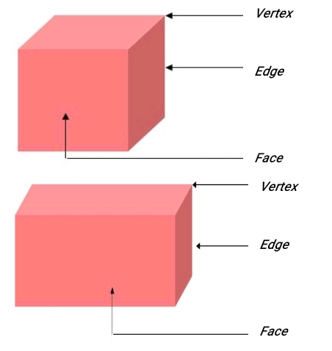  There are 6 faces, 12 edges and 8 vertices. | Previous knowledge
Step 2  Development  (5 minutes)  Grouping | 1. Groups the pupils into four groups – A, B, C, and D.  2. Guide the pupils to choose a leader and secretary for your group.  3. Gives each group learning materials – square and rectangular boxes | 1. Belong to a group.  2. Choose their leader and secretary.  3. Received learning materials for their group. | Pupil’s group, leader and secretary confirmed.
Step 3  Development  (5 minutes) | For the purpose of this lesson, guides the pupils identify the length, breadth (width) and height. | 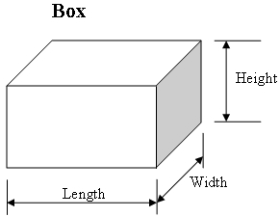 | Length, breadth and height of cube and cuboid
Step 4  Development  (15 minutes) | Guides pupils to measure the lengths, breadth (width) and heights of both cube and cuboid, compare the measurements and tell the difference.  After the activities, lets the pupils know that cube has square faces while cuboid has rectangular faces.. | Pupils measurements –  Cube – length ____, breadth ____, height ____.  Cuboid – length ____, breadth ____, height ____.  Pupils compared and see that in cube, all measurements are all the same and represents square.  While in cuboid, 2 opposite sides measured the same and represents rectangle. | Hands activities on cube and cuboid
Step 5  Conclusion/Evaluation  (10 minutes) | To conclude the lesson, the teacher revises the entire lesson and links it to the next lesson, and asks the key questions.  1. What is the different between cube and cuboid?  2. What are the properties of a cube and cuboid?  3. Cube and cuboid have how many faces, edges and vertices? | Listen, ask and answer questions. | Conclusion

