LESSON DEVELOPMENT THREE

FURTHER EXERCISES ON WEIGHT

STAGE/TIME | TEACHER’S ACTIVITIES | LEARNER'S ACTIVITIES – MIND/HANDS ON | LEARNING POINTS
Step 1  Introduction  (10 minutes) | Based on their previous knowledge and lessons, guides learners to develop fractions and decimals chart on weight.  Lets them these basic techniques –  1. To change from g to kg divide by 1000.  2. To change from kg to g multiply by 1000.  Note – Grams are used for small items, while kilograms are used for items bigger items. Tonne is greater than grams and kilograms used for items more bigger – like cars, containers, etc.  What form of measurement would you use for each of these: grams or kilograms?  1. Pencil  2. A bag of rice  3. Person  4. Textbook | Pupil’s chart  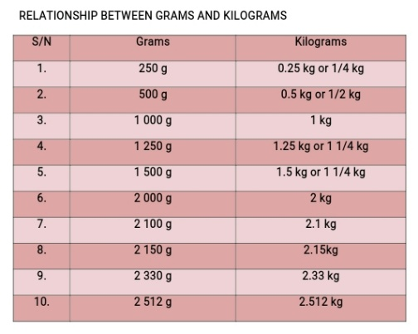  Pencil and textbook are measure in grams, while bag of rice and person measure in kilograms. | Linking the Previous knowledge to the new lesson
Step 2  Development  (5 minutes)  Grouping | 1. Groups the learners into four groups – A, B, C, and D.  2. Guide the learners to choose a leader and secretary for your group.  3. Gives each group learning materials. – units of weight – 5 000 grams = 5 kilogram, 10 kilograms = 10 000 kilograms. | 1. Belong to a group.  2. Choose their leader and secretary.  3. Received learning materials for their group. | Learner’s group, leader and secretary confirmed.
Step 3  Development  (10 minutes) | Working Examples –  Guides the learners to simplify –  1. 3 kg 120 g + 5 kg 450 g – 4 kg 670 g  2. 7 kg 716 g + 9 kg 575 g – 12 kg 714 g | Solution  1. 3 kg 120 g 2. 7 kg 716 g  + 5 kg 450 g + 9 kg 575 g  ____________ ____________  8 kg 570 g. 17 kg 281 g  – 4 kg 670 g - 12 kg 714 g  ____________ ____________  3 kg 900 g 4 kg 567 g | Working Examples
Step 4  Development  (10 minutes) | Working Exercises –  1. 13 kg 360 g + 2 kg 117 g – 8 kg 670 g  2. 77 kg 750 g + 41 kg 230 g – 36 kg 900 g | Solution –  1. 13 kg 360 g 2. 77 kg 750 g  + 2 kg 117 g + 41 kg 230 g  ____________ ____________  15 kg 477 g 77 kg 750 g  – 8 kg 670 g – 36 kg 900 g  ____________ ____________  6 kg 807 g 40 kg 850 g | Working Exercises
Step 5  Conclusion  (5 minutes) | To conclude the lesson, the teacher revises the entire lesson and ask the key questions.  Assignment  1. How many packets of lipton each weighing 500 g can be made from 5000 kg?  2. The total weight of ten parcels is 25.2 kg. Find the weight of one parcel. | The learners listen, ask and answer questions.  Assignment taken. | Lesson Evaluation and Conclusion  Assignment

