PHYSICAL AND HEALTH EDUCATION
FIRST TERM
EIGHT WEEK (BASIC 6)/NINTH WEEK (BASIC 5)
THEME: GAMES AND SPORTS
BASIC 5 AND 6
TOPIC: Football
Football is considered a game played by two teams of eleven (11) players on each side, using a round ball, which the players kick up and down on the playing field or any playing space.
A standard football game lasts for ninety (90) minutes; these ninety minutes can make a world of difference in the lives of many.
PERFORMANCE OBJECTIVES By the end of the lesson, the pupils should have attained the following objectives (cognitive, affective and psychomotor) and be able to narrate the history of football in Nigeria list the facilities and equipment in football; Draw and label a football pitch.
ENTRY BEHAVIOR The pupils are required to already have learned football in their previous classes.
INSTRUCTIONAL MATERIALS The teacher will teach the lesson with the aid of Textbook, Charts, Pictures, Video clips, Football pitch,Football, Whistle
METHOD OF Teaching Explanation, Discussion, Demonstration, Questions and Answers,
REFERENCE MATERIALSScheme of Work, 9 - Year Basic Education Curriculum, Course Book 6, All Relevant Books, Online Materials
CONTENT OF THE LESSON
HISTORY OF FOOTBALL IN NIGERIA
The Nigeria Football Federation (formerly known as Nigeria Football Association until 2008) is Nigeria’s football governing body. It was formally launched in 1945 and formed the first Nigerian national football team in 1949.[mediator_tech]
It joined Confederation of African Football (CAF) in 1959 and Federation of International Football Association (Fifa) in 1960. The Nigerian Football Federation (NFF) headquarters is located in the city of Abuja.
As of 2008 it organises three leagues: The Nigerian Premier League, the Amateur League and the Women's League, and five competitions, including the Federation Cup and Women's Cup.
FOOTBALL FACILITIES AND EQUIPMENT
The facilities and equipment in a football game are:
- The football pitch
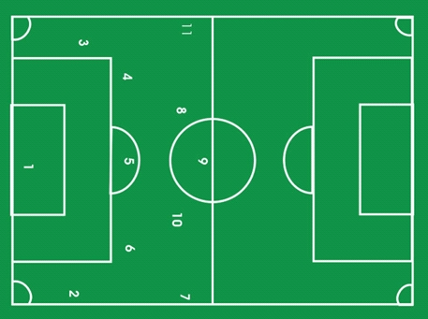]
- Goalkeeper
- Right fullback
- Left fullback
- Left halfback
- Centre halfback
- Right halfback
- Outside right
- Inside right
- Centre forward
- Inside left
- Outside left
- Goal post
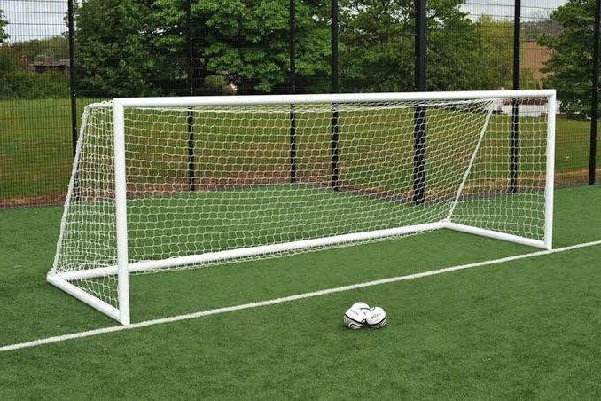
- Jersey
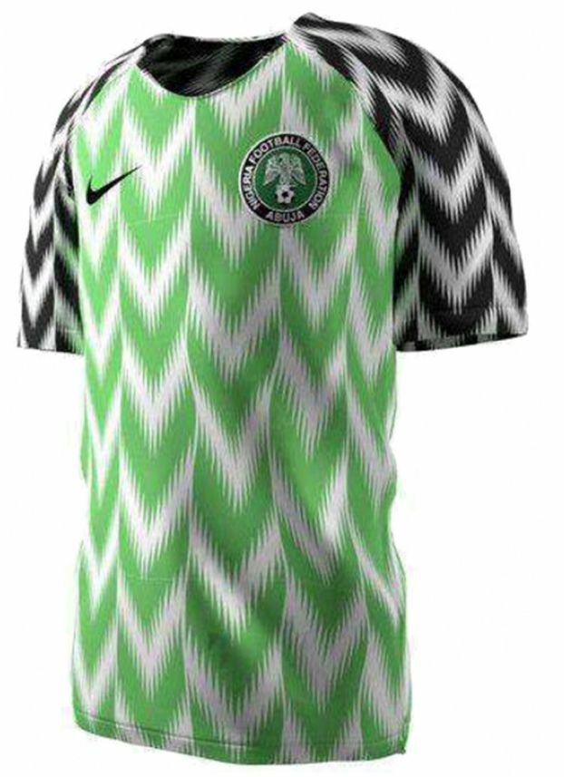[]

- Boat
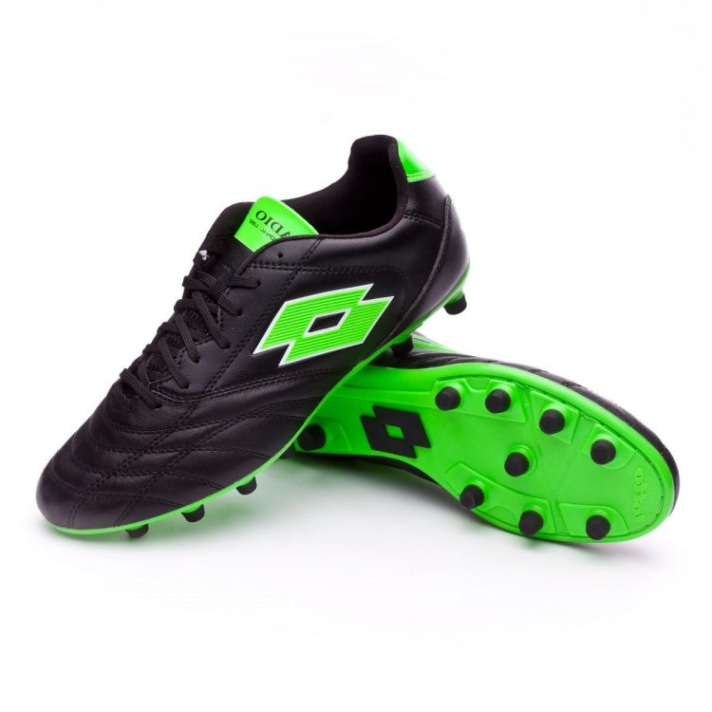
- Football
[]
DIMENSIONS OF FOOTBALL PITCH
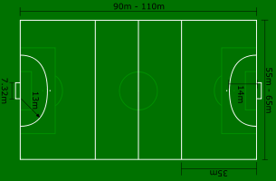
PRESENTATION
- To deliver the lesson, the teacher adopts the following steps:
- To introduce the lesson, the teacher revises the previous lesson. Based on this, he/she asks the pupils some questions;
- Narrates the history of football in Nigeria;
- Discusses the facilities and equipment;
- Pupil’s Activities – Listen to the teacher.
- Draws and labels football pitch;[mediator_tech]
- Pupil’s Activities - Draw and label the football pitch.
- Summarizes the major points on the board;
- Pupil’s Activities – write notes.
CONCLUSION
To conclude the lesson for the week, the teacher revises the entire lesson and links it to the following week’s lesson - football - rules and regulations.
LESSON EVALUATION
Pupils to:narrates the history of football in Nigeria; mention the facilities and equipment; draw and label football with dimensions.

