LESSON DEVELOPMENT ONE

IDEAS OF TEMPERATURE

STAGE/TIME | TEACHER’S ACTIVITIES | LEARNER'S ACTIVITIES – MIND/HANDS ON | LEARNING POINTS
Step 1  Introduction  (5 minutes) | Introduces item like water heater, ice block, cold water, warm water, thermometer, etc. On thinking of hot and cold.  Guides and asks the uses of these items.  Thermometer is used to measure temperature – how hot or cold something is. | Water heater is used for heating water. Ice block is used to make cold water or minerals. Cold or Warm water bathing.  Thermometer? | Linking the Previous knowledge to the new lesson
Step 2  Development  (5 minutes)  Grouping | 1. Groups the learners into four groups – A, B, C, and D.  2. Guide the learners to choose a leader and secretary for your group.  3. Gives each group learning materials. – pencil, book, ruler, and study charts. | 1. Belong to a group.  2. Choose their leader and secretary.  3. Received learning materials for their group. | Learner’s group, leader and secretary confirmed.
Step 3  Development  (20 minutes) | Lets the pupils the following pictures -  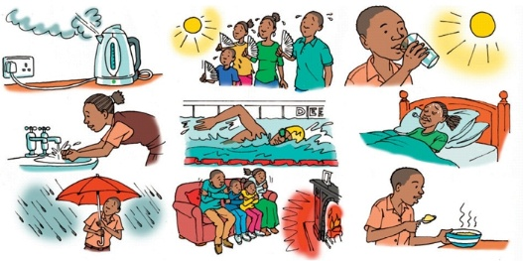  Asks – How will you describe each pictures as stated above? For example –  1. Boiling water in a kettle – very hot.  2. Water coming out of the tap –?  3. Rainfall –?  4. Family fanning themselves –?  5. A glass of cold water –?  6. Pupil swimming in a pool –?  7. Family surrounding a fireplace –?  8. A patient sick with fever –? 9. A bowl of hot custard –? | Response  2. ______________  3. ______________  4. ______________  5. ______________  6. ______________  7. ______________  8. ______________  9. ______________ | Oral Activity – hot or cold
Step 4  Development  (5 minutes) | Lets the pupils describe how hot or cold each of the situation.  Guides and lets them know that hot or cold describe temperature. That’s, the degree of hotness or coldness of an object. | Each situation is either cold or hot.  Temperature is the degree of hotness or coldness of an object. | Temperature
Step 5  Conclusion  (5 minutes) | To conclude the lesson, the teacher revises the entire lesson and ask the key questions.  1. What is temperature?  2. What can we use to measure temperature? | The learners listen, ask and answer questions.  Answers  1. Temperature is the degree of hotness or coldness of an object.  2. Thermometer | Lesson Evaluation and Conclusion

