LESSON DEVELOPMENT THREE

APPLICATIONS OF PULLEYS

STAGE/TIME | TEACHER’S ACTIVITIES | LEARNER'S ACTIVITIES – MIND/HANDS ON | LEARNING POINTS
Step 1  Introduction  (5 minutes) | 1. Describe a pulley.  2. State and describe the types of pulleys. | 1. A pulley consists of a rope and wheel mounted with axle.  2. There are three main types of pulleys: fixed, movable, and compound. | Linking the Previous knowledge to the new lesson
Step 2  Development  (5 minutes)  Grouping | 1. Groups the learners into four groups – A, B, C, and D.  2. Guide the learners to choose a leader and secretary for your group.  3. Gives each group learning materials. – Strings, Metal/wooden/plastic rollers, Nails and Wood. | 1. Belong to a group.  2. Choose their leader and secretary.  3. Received learning materials for their group. | Learner’s group, leader and secretary confirmed.
Step 3  Development  (10 minutes) | 1. Guides and lets each group to build a pulley.  2. Guides them demonstrate the application of pulley.  3. State 4 places where pulley is applicable. | HANDS ON ACTIVITIES | Pupils working in group
Step 4  Development  (10 minutes) | Asks each group to present their answers so that you can compare responses with those of other groups. | 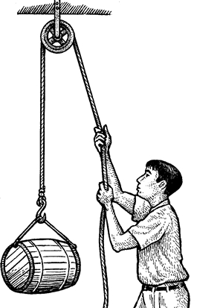 | Presentation
Step 5  Conclusion  (10 minutes) | To conclude the lesson, the teacher revises the entire lesson and ask the key questions.  KEY QUESTIONS  State 4 places where pulley is applicable. | The learners listen, ask and answer questions.  1. Motor mechanic’s workshop  2. Construction site  3. A wharf  4. At the well | Lesson Evaluation and Conclusion

