LESSON DEVELOPMENT ONE

SIMPLE MACHINES – PULLEYS

STAGE/TIME | TEACHER’S ACTIVITIES | LEARNER'S ACTIVITIES – MIND/HANDS ON | LEARNING POINTS
Step 1  Introduction  (5 minutes) | 1. What is simple machine?  2. List 3 types of simple machines? | 1. Simple machines are basic tools that make work easier.  2. Levers, Pulleys and inclined planes are the types of simple machines. | Linking the Previous knowledge to the new lesson
Step 2  Development  (5 minutes)  Grouping | 1. Groups the learners into four groups – A, B, C, and D.  2. Guide the learners to choose a leader and secretary for your group.  3. Gives each group learning materials. – chart showing water from the well with or without a pulley. Grinding stones and grinding machines, etc. | 1. Belong to a group.  2. Choose their leader and secretary.  3. Received learning materials for their group. | Learner’s group, leader and secretary confirmed.
Step 3  Development  (10 minutes) | 1. Lets pupils the compare –  a. grinding stones and grinding machine  b. water draw with or without pulley –  2. Which of these require little or more effort? | Pupil’s mind on activities  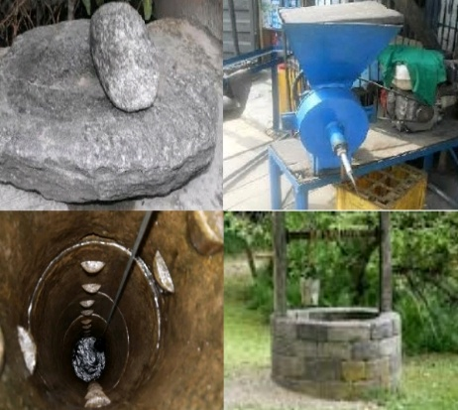 | MIND ON ACTIVITIES
Step 4  Development  (10 minutes) | Asks each group to present their answers so that you can compare responses with those of other groups.  Lets the group knows that grinding machine and machine used to draw water from a well are Pulleys. | Presentation
Step 5  Conclusion  (10 minutes) | To conclude the lesson, the teacher revises the entire lesson and ask the key questions.  SUMMARY – PULLEYS  A pulley is a simple machine that is used to lift heavy objects. Examples of pulleys are grinding machine, sowing machine, a crane, etc.  KEY QUESTIONS  1. What is pulley?  2. Give 4 examples of a pulley. | The learners listen, ask and answer questions. | Lesson Evaluation and Conclusion

