LESSON DEVELOPMENT ONE

TELLING THE TIME IN HOURS, HALF – HOURS AND QUARTER – HOURS

STAGE/TIME | TEACHER’S ACTIVITIES | LEARNER'S ACTIVITIES – MIND/HANDS ON | LEARNING POINTS
Step 1  Introduction  (5 minutes) | Asks the following key questions –  1. What says the time?  2. What is the time for assembly?  3. What time is the long break?  4. What is the time for closing time? | 1. 8:10 or 10 minutes after 8.  2. 8:00 o’clock.  3. 11:45 or quarter to 12. (some schools have break for junior and senior classes because population).  4. 2:00 o’clock for the senior classes. | Linking the Previous knowledge to the new lesson
Step 2  Development  (5 minutes)  Grouping | 1. Groups the learners into four groups – A, B, C, and D.  2. Guide the learners to choose a leader and secretary for your group.  3. Gives each group learning materials. – clocks and clock charts. | 1. Belong to a group.  2. Choose their leader and secretary.  3. Received learning materials for their group. | Learner’s group, leader and secretary confirmed.
Step 3  Development  (5 minutes) | What does the short and long hands in a clock stand for?  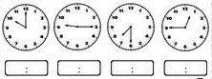  Guides pupils to tell the time in hours, half – hours and quarter – hours. | The short hand stands for hour and long hand stands for minutes.  Telling time in hours, half – hours and quarter – hours.  1. 10:00 o’clock.  2. Quarter after 9 or 9:15.  3. Half pass 7 or 7:30.  4. Quarter to 1 or 12:45. | Telling time in hours, half – hours and quarter – hours.
Step 4  Development  (10 minutes) | Guides and lets the groups write the times shown on the chart in two ways –  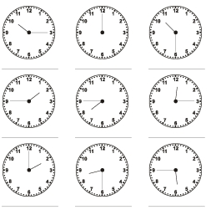 | Group Activities | Multiplication of weight in kilogram and gram
Step 5  Development  (10 minutes) | Asks each group to present their answers so that you can compare responses with those of other groups. | Presentation  1. 10:15 or quarter pass/after 10.  2. 12:00 noon. | Group Presentation
Step 6  Conclusion  (5 minutes) | To conclude the lesson, the teacher revises the entire lesson and ask the key questions.  Assignment  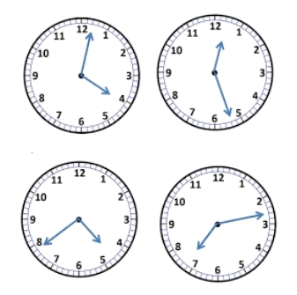 | The learners listen, ask and answer questions. | Lesson Evaluation and Conclusion

