LESSON DEVELOPMENT TWO

TELL ON THE CLOCK IN MINUTES AND HOURS

STAGE/TIME | TEACHER’S ACTIVITIES | LEARNER'S ACTIVITIES – MIND/HANDS ON | LEARNING POINTS
Step 1  Introduction  (5 minutes) | Checks pupils homework and guides them to tell the times correctly.  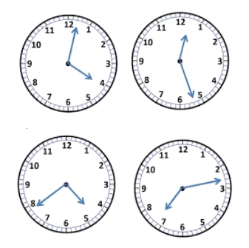 | Telling time in minutes and second –  1. 4:39  2. 12:27  3. 4:39  4. 7:13 | Linking the Previous knowledge to the new lesson
Step 2  Development  (5 minutes)  Grouping | 1. Groups the learners into four groups – A, B, C, and D.  2. Guide the learners to choose a leader and secretary for your group.  3. Gives each group learning materials. – clocks and clock charts. | 1. Belong to a group.  2. Choose their leader and secretary.  3. Received learning materials for their group. | Learner’s group, leader and secretary confirmed.
Step 3  Development  (5 minutes) | Guides pupils to draw the hands on the clock face.  Note - The short hand stands for hand hour and short hand stands for minutes hand.  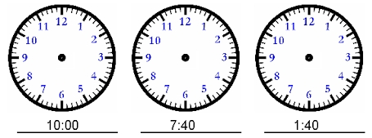 | HANDS ON ACTIVITIES | Draw the hands on the clock face.
Step 4  Development  (10 minutes) | Draw the hands on clock face –  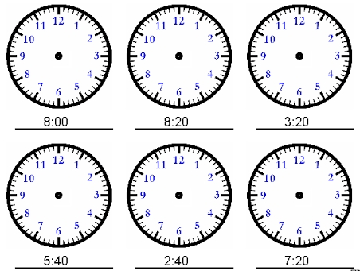 | Group Activities | Draw the hands on clock face.
Step 5  Development  (10 minutes) | Asks each group to present their answers so that you can compare responses with those of other groups. | Presentation | Group Presentation
Step 6  Conclusion  (5 minutes) | To conclude the lesson, the teacher revises the entire lesson and ask the key questions.  Assignment  Draw a clock to show each of the following times –  1. 8.55  2. 6.15  3. 1.24  4. 2.38  5. 5.30 | The learners listen, ask and answer questions. | Lesson Evaluation and Conclusion

