LESSON DEVELOPMENT THREE

USING THE A.M AND P.M NOTATION FOR THE TIME OF THE DAY

STAGE/TIME | TEACHER’S ACTIVITIES | LEARNER'S ACTIVITIES – MIND/HANDS ON | LEARNING POINTS
Step 1  Introduction  (5 minutes) | Write in time –  1. Twenty minutes past ten in the morning.  2. Half past three in the afternoon.  Lets pupils know that time in the morning is written as 10:20 am. Time in the afternoon is written as 3:30 pm. | 1. 10:20  2. 3:30 | Linking the Previous knowledge to the new lesson
Step 2  Development  (5 minutes)  Grouping | 1. Groups the learners into four groups – A, B, C, and D.  2. Guide the learners to choose a leader and secretary for your group.  3. Gives each group learning materials. – clocks and clock charts. | 1. Belong to a group.  2. Choose their leader and secretary.  3. Received learning materials for their group. | Learner’s group, leader and secretary confirmed.
Step 3  Development  (5 minutes) | 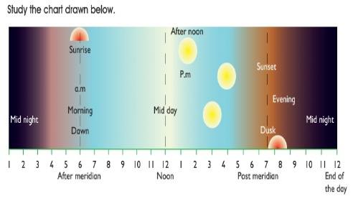  From From chart above;  Lets the pupils know that –  1. 12 midnight to 12 noon (midday) is known as ante meridian (a.m).  2. 12 noon (midday) to 12 midnight again is known as post – meridian (p.m).  Note – communicate the above in the language they will understand, preferably mother tongue. | Pupils study the chart, listen and ask questions if they don’t understand.  Teacher – pay attention to them both verbal and non – verbal. | A.m and p.m
Step 4  Development  (10 minutes) | Groups exercises –  Write out these times using a.m. or p.m.  1. The time when the school assembly begins at 7.30.  2. The time when the school closes at 2 o’clock.  3. The time when you have your dinner at 7 o’clock.  4. The time when you go to bed at 9 o’clock  5. The time when daddy comes back from work at 5 o’clock.  6. The time when we have break at 12.05.  7. Quarter past three in the morning.  8. Eighteen minutes to six in the evening.  9. Half past eleven in the morning.  10. Twenty minutes to three in the afternoon. | Group Activities | Conversion of unit of time
Step 5  Development  (10 minutes) | Asks each group to present their answers/results/solutions so that you can compare responses with those in other groups. | Presentation  8. P.m  9. A.m  10. P.m | Group Presentation
Step 6  Conclusion  (5 minutes) | To conclude the lesson, the teacher revises the entire lesson and ask the key questions.  Assignment  Copy and complete the following statements. The first one is done for you.  1. Four hours after midnight is 4 a.m  2. Three hours before midnight is.  3. Nine hours after midnight is.  4. Five hours after midday is.  5. Eleven hours after midday is.  6. Two hours before midday. | The learners listen, ask and answer questions. | Lesson Evaluation and Conclusion

Reference book – New Method Mathematics Book 4.

