LESSON DEVELOPMENT ONE

PARALLEL AND PERPENDICULAR LINES

STAGE/TIME | TEACHER’S ACTIVITIES | LEARNER'S ACTIVITIES – MIND/HANDS ON | LEARNING POINTS
Step 1  Introduction  (5 minutes) | Presents chart of cuboid or cube and and the real object of cuboid or cube – carton.  ABCDEFGH is a cube placed on a table.  Guides and lets the pupils copy and complete these statements using the figure.  1. _____ and _____ are the horizontal faces.  2. The vertical faces are _____, _____, _____ and _____.  3. There are _____ horizontal edges.  4. There are _____ vertical edges. | 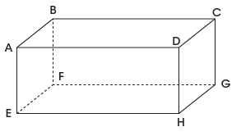  Results  1. ABCD and EFGH are horizontal faces.  2. ABEF, ADHE, CDHG, and BCFG are vertical faces.  3. 8 horizontal edges.  4. 16 vertical edges.  Note – each face has 4 edges. | Linking the Previous knowledge to the new lesson
Step 2  Development  (5 minutes)  Grouping | 1. Groups the learners into four groups – A, B, C, and D.  2. Guide the learners to choose a leader and secretary for your group.  3. Gives each group learning materials. – chart of parallel and perpendicular lines, 2 and 3 dimensional shapes. | 1. Belong to a group.  2. Choose their leader and secretary.  3. Received learning materials for their group. | Learner’s group, leader and secretary confirmed.
Step 3  Development  (5 minutes) | 1. Observe the lines drawn on the chart.  2. Use your ruler to measure the length between each line.  3. What do you observe?  Lets pupils know that the lines are called parallel lines. | 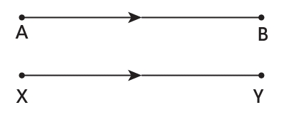  Measurements  AB _____ XY _____  Observations  The lines are equal and lines. | Parallel Lines
Step 4  Development  (5 minutes) | 1. Observe the lines drawn on the chart.  2. What do you observe?  Yes, the lines are intercept and both are called perpendicular lines. | 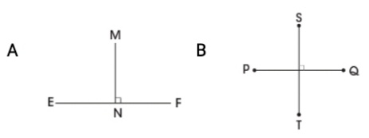  Observation  The lines are intercept. | Perpendicular Lines
Step 5  Development  (5 minutes) | Groups exercises –  1. Name a line parallel to AB.  2. Name a line parallel to GH.  3. Name two lines that are perpendicular to AB and pass through A.  4. Name two lines that are perpendicular to AB and pass through B. | Group Activities | Conversion of unit of time
Step 6  Development  (10 minutes) | Asks each group to present their results/solutions so that you can compare responses with those in other groups. | Presentation  1. EF  4. AE and AD | Group Presentation
Step 7  Conclusion  (5 minutes) | To conclude the lesson, the teacher revises the entire lesson and ask the key questions.  Assignment  Mention 5 parallel and perpendicular lines with their corresponding lines. | The learners listen, ask and answer questions. | Lesson Evaluation and Conclusion

Reference book – New Method Mathematics Book 4.

