LESSON DEVELOPMENT TWO

PROPERTIES OF QUADRILATERAL

STAGE/TIME | TEACHER’S ACTIVITIES | LEARNER'S ACTIVITIES – MIND/HANDS ON | LEARNING POINTS
Step 1  Introduction  (5 minutes) | Introductory Activities – Drawing four sided shape.  1. Draw a line.  2. Draw another line from the starting or end of the first line.  3. Draw another line from other end.  4. Draw one more to join the four lines together.  5. How many lines altogether?  6. What do you observe?  7. What shape is this?  8. This shape has many corners?  Note – Lets pupils know that the shape is called quadrilateral. | 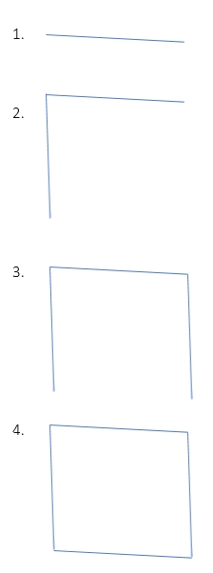  HANDS ON ACTIVITIES –  5. 4 lines.  6. Observing  7. A shape.  8. 4 corners. | Linking the Previous knowledge to the new lesson
Step 2  Development  (5 minutes)  Grouping | 1. Groups the learners into four groups – A, B, C, and D.  2. Guide the learners to choose a leader and secretary for your group.  3. Gives each group learning materials – chart and sample of different quadrilaterals (square and rectangle), 2 and 3 dimensional shapes. | 1. Belong to a group.  2. Choose their leader and secretary.  3. Received learning materials for their group. | Learner’s group, leader and secretary confirmed.
Step 3  Development  (5 minutes) | QUADRILATERALS  1. Name the 4 corners A, B, C and D.  If the side between A and B is called AB.  The side between A and C is called AC.  2. Side between A and C, B and C, C and D are called _____________.  The angle at:  If corner A is called angle A or A, what is corner B, C and D? | Listen to teacher’s comments.  2. Side between A and C is called AC.  Side between B and C is called BC.  Side between C and D is called CD.  3. Corner B is called angle B or B.  Corner C is called angle C or C.  Corner D is called angle D or D. | Properties of Quadrilateral
Step 4  Development  (5 minutes) | TYPES OF QUADRILATERAL  1. Study the chart.  2. Name the sides of each triangle ABCD.  3. Measure AB, AC, BC and CD of each quadrilateral.  4. Record your measurements.  5. What is your observations.  6. What are the names of these 2 shapes? | Groups work  3/4. Square –  AB _______  AC _______  BC _______  Second Rectangle –  AB _______  AC _______  BC _______  CD _______  5. Observations –  First Square – all sides are equal.  Second Rectangle – out of 4 lines, 2 lines are equal and the 2 ramaining lines are equal too.  6…..? | Types of quadrilateral and their properties.
Step 5  Development  (10 minutes) | Asks each group to present their results/solutions so that you can compare responses with those in other groups. | Presentation | Group Presentation
Step 7  Conclusion  (5 minutes) | To conclude the lesson, the teacher revises the entire lesson and ask the key questions.  SUMMARY  The first and second shapes are square and rectangle. There are many types of quadrilateral. Other are trapezium, rhombus, kite, and parallelogram.  Assignment  Draw the following shapes –  1. Trapezium  2. Rhombus  3. Kite  4. Parallelogram | The learners listen, ask and answer questions. | Lesson Evaluation and Conclusion

Reference book – New Method Mathematics Book 5.

