LESSON DEVELOPMENT TWO

PROPERTIES OF TRIANGLES

STAGE/TIME | TEACHER’S ACTIVITIES | LEARNER'S ACTIVITIES – MIND/HANDS ON | LEARNING POINTS
Step 1  Introduction  (5 minutes) | Introductory Activities –  1. Draw a line.  2. Draw another line from the starting or end of the first line.  3. How many lines have you drawn?  4. Draw another line to join the first and second lines together.  5. How many lines altogether?  6. What do you observe?  7. What shape is this?  8. Triangle has many corners?  Note – Lets pupils know that the 3 corners of triangle is called vertices. | HANDS ON ACTIVITIES –  1.  2.  3. 3 lines.  4.  5. 3 lines.  6. Observation.  7. Triangle.  8. 3 corners. | Linking the Previous knowledge to the new lesson
Step 2  Development  (5 minutes)  Grouping | 1. Groups the learners into four groups – A, B, C, and D.  2. Guide the learners to choose a leader and secretary for your group.  3. Gives each group learning materials – chart and sample of triangles, 2 and 3 dimensional shapes. | 1. Belong to a group.  2. Choose their leader and secretary.  3. Received learning materials for their group. | Learner’s group, leader and secretary confirmed.
Step 3  Development  (5 minutes) | TRIANGLE  1. Name the 3 corners A, B and C.  Teacher’s comments – The triangle is called triangle ABC.  If the side between A and B is called AB.  The side between A and C is called AC.  2. Side between A and C, B and C are called _____________.  The angle at:  If corner A is called angle A or A, what is corner B and C? | 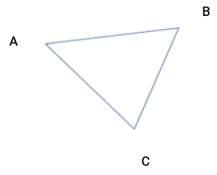  Listen to teacher’s comments.  2. Side between A and C is called AC.  Side between B and C is called BC.  3. Corner B is called angle B or B.  Corner C is called angle C or C. | Properties of Triangle
Step 4  Development  (5 minutes) | TYPES OF TRIANGLES  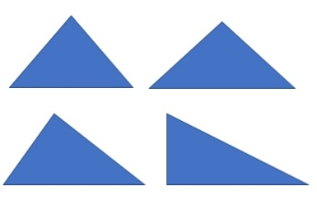  1. Study the chart.  2. Name the sides of each triangle ABC.  3. Measure AB, AC and BC of each triangle.  4. Record your measurements.  5. What is your observations. | Groups work  3/4. First triangle –  AB _______  AC _______  BC _______  Second triangle –  AB _______  AC _______  BC _______  Third triangle –  AB _______  AC _______  BC _______  5. Observations –  First triangle, all sides are equal.  Second triangle, 2 of its sides are equal.  Third triangle, no equal side. | Types of Triangle and their properties.
Step 5  Development  (10 minutes) | Asks each group to present their results/solutions so that you can compare responses with those in other groups. | Presentation | Group Presentation
Step 7  Conclusion  (5 minutes) | To conclude the lesson, the teacher revises the entire lesson and ask the key questions.  SUMMARY  First triangle is called equilateral triangle. Second triangle is called isosceles triangle while the third triangle is called scalene triangle. The fourth triangle is a right - angle triangle. One of its angles is at 90°.  Assignment  1. What is a triangle?  2. How many types of triangle do we have?  3. Name them.  4. What are the properties or characteristics of each types of triangle? | The learners listen, ask and answer questions. | Lesson Evaluation and Conclusion

Reference book – New Method Mathematics Book 4.

