LESSON DEVELOPMENT THREE

ANGLES ON A STRAIGHT LINE AND ANGLES AT A POINT

STAGE/TIME | TEACHER’S ACTIVITIES | LEARNER'S ACTIVITIES – MIND/HANDS ON | LEARNING POINTS
Step 1  Introduction  (5 minutes) | Introductory Activities – Guides the pupils to  1. Draw a straight line and name it line AB.  2. Place your protractor on the straight line.  3. Take your reading from A (at 0°) to B (at 180°).  3. What is angle on a straight line? | MIND ON ACTIVITIES –  A B  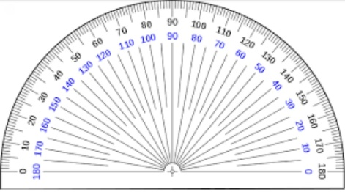  Angle on a straight line is 180°. | Linking the Previous knowledge to the new lesson
Step 2  Development  (5 minutes)  Grouping | 1. Groups the learners into four groups – A, B, C, and D.  2. Guide the learners to choose a leader and secretary for your group.  3. Gives each group learning materials – mathematical set, clock, chart of different angles and plain paper. | 1. Belong to a group.  2. Choose their leader and secretary.  3. Received learning materials for their group. | Learner’s group, leader and secretary confirmed.
Step 3  Development  (10 minutes) | 1. Draw two straight lines to intersect.  2. Name all the angles formed a, b, c and d respectively.  3. Use your protractor to measure each angle – guide them.  4. Add all the 4 angles together.  Point to know – angle on a straight line equal to 180°. Angles on 2 straight lines equal to 360°.  5. What are angles on the first and second straight lines?  6. Add together angles on each straight lines together.  Point to note - ∠ a and ∠ c are opposite each other. Likewise ∠ b and ∠ d are opposite each other. The two angles that are opposite each other are called vertically opposite angles. | 1. & 2.  a b  c d  3. Measurements –  ∠ a = ____,  ∠ b = ____,  ∠ c = ____, and  ∠ d = ____.  4. ∠ a + ∠ b + ∠ c + ∠ d = 360°  5. 1st line, ∠ a and ∠ b. 2nd line ∠ c and ∠ d.  6. 1st line, ∠ a + ∠ b = 180°.  2nd line, ∠ c + ∠ d = 180 °. | Measuring of Angles using protractor.
Step 4  Development  (10 minutes) | Calculate the size of each marked angle. | 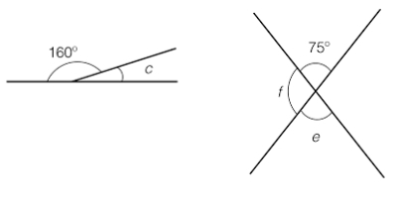  Groups Activities | Measurement of angles using clock.
Step 10  Development  (10 minutes) | Asks each group to present their results/solutions so that you can compare responses with those in other groups. | Presentation  1. Angles on a straight line is 180°.  Therefore, 160° + c = 180°  c = 180° - 160° = 20° | Group Presentation
Step 6  Conclusion  (5 minutes) | To conclude the lesson, the teacher revises the entire lesson and ask the key questions.  KEY QUESTIONS  1. What is the different between angles on a straight line and angles at a point.  2. The two angles that are opposite each other are called ___________  (a) vertically opposite  (b) horizontally opposite  (c) adjacent  ASSIGNMENT  3. Calculate angle ∠ m.  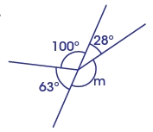 | The learners listen, ask and answer questions. | Lesson Evaluation and Conclusion

Reference book – New Method Mathematics Book 5.

