LESSON DEVELOPMENT ONE

INTRODUCTION TO ANGLES

STAGE/TIME | TEACHER’S ACTIVITIES | LEARNER'S ACTIVITIES – MIND/HANDS ON | LEARNING POINTS
Step 1  Introduction  (5 minutes) | Introductory Activities –  1. Draw a straight line.  2. Draw another line from the starting or end of the first line.  Point to note for the pupils - The point of intersection of the lines is called the corner or vertex. | HANDS ON ACTIVITIES – | Linking the Previous knowledge to the new lesson
Step 2  Development  (5 minutes)  Grouping | 1. Groups the learners into four groups – A, B, C, and D.  2. Guide the learners to choose a leader and secretary for your group.  3. Gives each group learning materials – mathematical set and plain paper. | 1. Belong to a group.  2. Choose their leader and secretary.  3. Received learning materials for their group. | Learner’s group, leader and secretary confirmed.
Step 3  Development  (5 minutes) | ANGLES  Angles are the space between two or more line that meet. If two lines meet (or intersect) at a point, then an angle is formed.  Name the 3 points of the two lines A, B and C.  Lines AB and AC meet at the point A to form an angle.  The corner A is called angle. Written as ∠ BAC or ∠ CAB. | 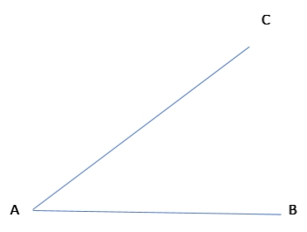 | Angle
Step 4  Development  (5 minutes) | TYPES OF ANGLES  Angles range from 0° to 360° are group into –  1. Acute angles – less than 90°.  2. A right angle – exactly 90°.  3. Obtuse angles – greater than 90° and less than 180°  4. Angle on a straight line – 180°  5. A reflex angle – greater than 180° but less than 360°  6. Full angle – exactly 360°. | Listen to teacher and give examples of –  1. Acute angles  2. Obtuse angles  3. Reflex angles.  Identify –  4. 90°  5. 180°  6. 360°. | Types of Triangle and their properties.
Step 5  Development  (5 minutes) | Exercises – group the following angles into acute, obtuse, reflex, right and full angles.  1. 62°  2. 53°  3. 141°  4. 90°  5. 65°  6. 127°  7. 40°  8. 136°  9. 270°  10. 360° | Groups Activities | Group work
Step 6  Development  (10 minutes) | Asks each group to present their results/solutions so that you can compare responses with those in other groups. | Presentation | Group Presentation
Step 7  Conclusion  (5 minutes) | To conclude the lesson, the teacher revises the entire lesson and ask the key questions.  KEY QUESTIONS  1. What is angle?  2. Mention the 6 types of Angles.  3. How does an angle formed? | The learners listen, ask and answer questions. | Lesson Evaluation and Conclusion

Reference book – New Method Mathematics Book 5.

