LESSON DEVELOPMENT TWO

MEASURING OF ANGLES

STAGE/TIME | TEACHER’S ACTIVITIES | LEARNER'S ACTIVITIES – MIND/HANDS ON | LEARNING POINTS
Step 1  Introduction  (5 minutes) | Introductory Activities –  1. What is this object called?  2. What is it used for?  3. How many hands does it has?  4. What is the different between both hands?  Point to note for the pupils – When two lines meet (or intersect) at a point, then an angle is formed.  The minutes and hour hands represent the two lines. The space between minute and hour hands make an angle. | 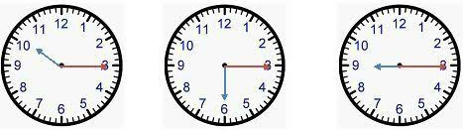  MIND ON ACTIVITIES –  1. Clock.  2. It is used for telling time.  3. It has two hands  4. The first hand is called hour hand, and it is short. The second hand is called minute hand, and it is long. | Linking the Previous knowledge to the new lesson
Step 2  Development  (5 minutes)  Grouping | 1. Groups the learners into four groups – A, B, C, and D.  2. Guide the learners to choose a leader and secretary for your group.  3. Gives each group learning materials – mathematical set, clock, chart of different angles and plain paper. | 1. Belong to a group.  2. Choose their leader and secretary.  3. Received learning materials for their group. | Learner’s group, leader and secretary confirmed.
Step 3  Development  (5 minutes) | Measuring of Angles using clock  1. Write the time shown on each clock face.  A Full Angle is an angle that has a measure of exactly 360°.  1 minute = 6°  2 minutes = 12°  60 minutes = 360°  2. Write the angles between minute and hour hands. | 1. 10:15  15 m = 15 x 6°  = 90°  2. 3:30  30 m = 30 x 15°  = 180°  3. 9:45  45 m = 45 x 6°  = 270° | Angles between minute and hour hands.
Step 4  Development  (10 minutes) | Measure the following angles using clock.  Guided instructions –  1. Draw 2 straight lines perpendicular to one another across the intersection.  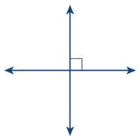  2. Draw a circle around the perpendicular lines.  3. Number the circumference like the face of a clock.  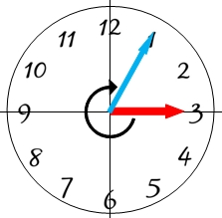  4. Find the minutes and multiply by 6°. | 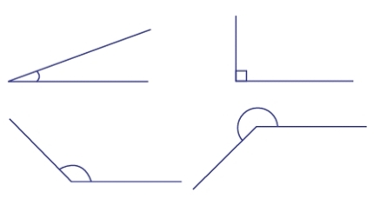  Groups Activities | Measurement of angles using clock.
Step 10  Development  (10 minutes) | Asks each group to present their results/solutions so that you can compare responses with those in other groups. | Presentation | Group Presentation
Step 6  Conclusion  (5 minutes) | To conclude the lesson, the teacher revises the entire lesson and ask the key questions.  SUMMARY | The learners listen, ask and answer questions. | Lesson Evaluation and Conclusion

Reference book – New Method Mathematics Book 5.

