LESSON DEVELOPMENT FOUR

SUM OF ANGLES IN TRIANGLES

STAGE/TIME | TEACHER’S ACTIVITIES | LEARNER'S ACTIVITIES – MIND/HANDS ON | LEARNING POINTS
Step 1  Introduction  (5 minutes) | Introductory Activities –  1. Draw a line.  2. Draw another line from the starting or end of the first line.  3. How many lines have you drawn?  4. Draw another line to join the first and second lines together.  5. How many lines altogether?  6. What do you observe?  7. What shape is this?  8. Triangle has many corners?  Note – Lets pupils know that the 3 corners of triangle is called vertices. | HANDS ON ACTIVITIES –  1.  2.  3. 3 lines.  4.  5. 3 lines.  6. Observation.  7. Triangle.  8. 3 corners. | Linking the Previous knowledge to the new lesson
Step 2  Development  (5 minutes)  Grouping | 1. Groups the learners into four groups – A, B, C, and D.  2. Guide the learners to choose a leader and secretary for your group.  3. Gives each group learning materials – chart and sample of triangles, 2 and 3 dimensional shapes. | 1. Belong to a group.  2. Choose their leader and secretary.  3. Received learning materials for their group. | Learner’s group, leader and secretary confirmed.
Step 3  Development  (5 minutes)  If the side between A and B is called AB.  If corner A is called angle A or ∠ A. | TRIANGLE  1. Name the 3 corners A, B and C.  Teacher’s comments – The triangle is called triangle ABC.  2. The side between A and C is called AC. Side between B and C are called _____________.  The angle at:  What is corner B and C?  Point to note – angle A is written as ∠ BAC or CAB.  4. How is angles B and C are written? | 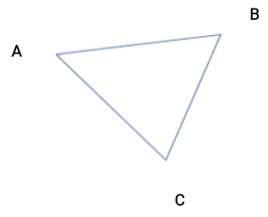  Listen to teacher’s comments.  2. Side between B and C is called BC.  3. Corner B is called angle B or ∠ B.  Corner C is called angle C or ∠ C.  4. Angle B is written as ∠ ABC or CBA. While angle C is written as ∠ ACB or BCA. | Properties of Angle
Step 4  Development  (10 minutes) | Measuring Angles in a Triangle  1. Study and Name each triangle ABC, then easure the angles following triangles –  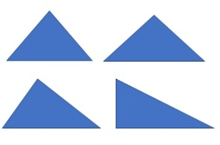  2. Record your measurements.  3. Add all the 3 angles in a triangle together.  4. Observe and record your observations. | Groups Activities –  1st, 2nd, & 3rd Instructions Studying and recording –  First triangle,  ∠ A = _____  ∠ B = _____  ∠ C = _____  Sum of angles = _____  Second triangle,  ∠ A = _____  ∠ B = _____  ∠ C = _____  Sum of angles = _____  Third triangle,  ∠ A = _____  ∠ B = _____  ∠ C = _____  Sum of angles = _____  Fourth triangle,  ∠ A = _____  ∠ B = _____  ∠ C = _____  Sum of angles = _____  4. Observation | Sum of Angles in a Triangle.
Step 5  Development  (10 minutes) | Asks each group to present their results/solutions so that you can compare responses with those in other groups. | Presentation  First triangle,  ∠ A = 60°  ∠ B = 60°  ∠ C = 60°  Sum of angles  = 60° + 60° + 60° = 180° | Group Presentation
Step 7  Conclusion  (5 minutes) | To conclude the lesson, the teacher revises the entire lesson and ask the key questions.  SUMMARY  The sum of angles in a triangle is 180°.  ASSIGNMENT  Find the missing angle in each of the following:  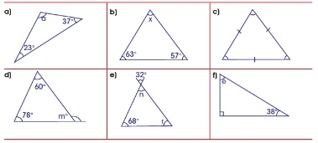 | The learners listen, ask and answer questions. | Lesson Evaluation and Conclusion

Reference book – New Method Mathematics Book 6.

