LESSON PLAN/NOTE FOR THE WEEK 3

13th MAY/16TH MAY, 2019
BASIC INFORMATIONS

- TEACHER: ALABI M. S.
- SCHOOL: IJORA OLOYE NURSERY AND PRIMARY SCHOOL
- TERM: 3nd TERM
- DURATION: 40 MINUTES
- CLASS: PRIMARY 4 5 6
- SUBJECT MATHEMATICS

LESSON PLAN/LEARNING AREA FOR WEEK 2

- PRIMARY 4
Lesson One - Introduction to Time - Quarter to/after and Half past
Lesson Two - Tell on the Clock in Minutes and Hours
Lesson Three - Relationship between Seconds, Minutes and Hours
Lesson Four - Using the A.m and P.m Notation for the Time of the Day
- PRIMARY 5
Lesson One - Parallel and Perpendicular Lines
Lesson Two - Triangles and Properties of Triangle
Lesson Three - Quadrilateral and Properties of Quadrilateral
Lesson Four - Quantitative Reasoning
Lesson Five - Revision and Test
- PRIMARY 6
Lesson One - Introduction to Angles
Lesson Two - Measurement of Angles
Lesson Three - Angles on A Straight Line and Angles at A Point
Lesson Four - Sum of Angles in A Triangle
Lesson Five - Quantitative, Revision and Test
PRIMARY 4
TOPIC: Time on the Clock
LEARNING OUTCOME By the end of the lesson, pupils should be able to:
- give time on the clock, read calendar and write dates.
- use the notation am and pm for the time of the day.
- tell the time in hours, half-hours and quarter-hours.
- tell the time in minutes and seconds.
- convert the unit of time.
- solve quantitative aptitude problems related to time.
RATIONALE The concept of time is self-evident. An hour consists of a certain number of minutes, a day of hours and a year of days. Time is passing non-stop, and we follow it with clocks and calendars. it still keeps passing. We just cannot say what exactly happens when time passes. Time wait for nobody. It keeps us in check and balance. In lesson, the pupils will learn and appreciate the importance of time and able to tell time correctly.
LEARNING MATERIALS The teacher will teach the lesson with the aid of Clocks, Calendars and Clock charts.
PREVIOUS KNOWLEDGE Time is something we deal with every day. The teacher and his/her pupils worked with time always. From the time of assembly, lessons, short/long break and the closing time. At home, time for prayer, to eat, etc.
LESSON DEVELOPMENT ONE - TELLING THE TIME IN HOURS, HALF – HOURS AND QUARTER – HOURS

STAGE/TIME | TEACHER’S ACTIVITIES | LEARNER'S ACTIVITIES – MIND/HANDS ON | LEARNING POINTS
Step 1  Introduction  (5 minutes) | Asks the following key questions –  1. What says the time?  2. What is the time for assembly?  3. What time is the long break?  4. What is the time for closing time? | 1. 8:10 or 10 minutes after 8.  2. 8:00 o’clock.  3. 11:45 or quarter to 12. (some schools have break for junior and senior classes because population).  4. 2:00 o’clock for the senior classes. | Linking the Previous knowledge to the new lesson
Step 2  Development  (5 minutes)  Grouping | 1. Groups the learners into four groups – A, B, C, and D.  2. Guide the learners to choose a leader and secretary for your group.  3. Gives each group learning materials. – clocks and clock charts. | 1. Belong to a group.  2. Choose their leader and secretary.  3. Received learning materials for their group. | Learner’s group, leader and secretary confirmed.
Step 3  Development  (5 minutes) | What does the short and long hands in a clock stand for?  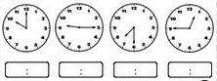  Guides pupils to tell the time in hours, half – hours and quarter – hours. | The short hand stands for hour and long hand stands for minutes.  Telling time in hours, half – hours and quarter – hours.  1. 10:00 o’clock.  2. Quarter after 9 or 9:15.  3. Half pass 7 or 7:30.  4. Quarter to 1 or 12:45. | Telling time in hours, half – hours and quarter – hours.
Step 4  Development  (10 minutes) | Guides and lets the groups write the times shown on the chart in two ways –  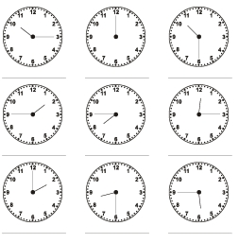 | Group Activities | Multiplication of weight in kilogram and gram
Step 5  Development  (10 minutes) | Asks each group to present their answers so that you can compare responses with those of other groups. | Presentation  1. 10:15 or quarter pass/after 10.  2. 12:00 noon. | Group Presentation
Step 6  Conclusion  (5 minutes) | To conclude the lesson, the teacher revises the entire lesson and ask the key questions.  Assignment  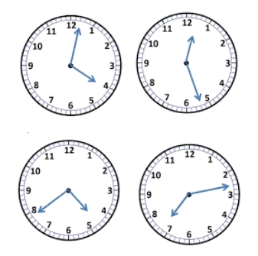 | The learners listen, ask and answer questions. | Lesson Evaluation and Conclusion

LESSON DEVELOPMENT TWO - TELL TIME ON THE CLOCK IN MINUTES AND HOURS

STAGE/TIME | TEACHER’S ACTIVITIES | LEARNER'S ACTIVITIES – MIND/HANDS ON | LEARNING POINTS
Step 1  Introduction  (5 minutes) | Checks pupils homework and guides them to tell the times correctly. | Telling time in minutes and second –  1. 4:39  2. 12:27  3. 4:39  4. 7:13 | Linking the Previous knowledge to the new lesson
Step 2  Development  (5 minutes)  Grouping | 1. Groups the learners into four groups – A, B, C, and D.  2. Guide the learners to choose a leader and secretary for your group.  3. Gives each group learning materials. – clocks and clock charts. | 1. Belong to a group.  2. Choose their leader and secretary.  3. Received learning materials for their group. | Learner’s group, leader and secretary confirmed.
Step 3  Development  (5 minutes) | Guides pupils to draw the hands on the clock face.  Note - The short hand stands for hand hour and short hand stands for minutes hand.  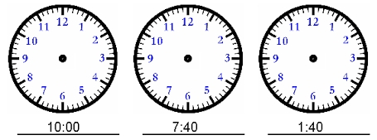 | HANDS ON ACTIVITIES | Draw the hands on the clock face.
Step 4  Development  (10 minutes) | Draw the hands on clock face –  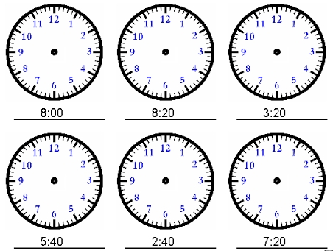 | Group Activities | Draw the hands on clock face.
Step 5  Development  (10 minutes) | Asks each group to present their answers so that you can compare responses with those of other groups. | Presentation | Group Presentation
Step 6  Conclusion  (5 minutes) | To conclude the lesson, the teacher revises the entire lesson and ask the key questions.  Assignment  Draw a clock to show each of the following times –  1. 8.55, 2. 6.15, 3. 1.24, 4. 2.38, 5. 5.30 | The learners listen, ask and answer questions. | Lesson Evaluation and Conclusion

LESSON DEVELOPMENT THREE - SECONDS, MINUTES AND HOURS

STAGE/TIME | TEACHER’S ACTIVITIES | LEARNER'S ACTIVITIES – MIND/HANDS ON | LEARNING POINTS
Step 1  Introduction  (5 minutes) | Lets pupils copy and complete the following -  1. 60 seconds = _____ minute  2. 60 minutes = _____ hour  3. 24 hours =_____ day  4. 30 days = _____ month  5. 12 months = _____ year  6. 365 days = _____ year | 1. 60 seconds = 1 minute  2. 60 minutes = 1 hour  3. 24 hours = 1 day  4. 30 days = 1 month  5. 12 months = 1 year  6. 365 days = 1 year | Linking the Previous knowledge to the new lesson
Step 2  Development  (5 minutes)  Grouping | 1. Groups the learners into four groups – A, B, C, and D.  2. Guide the learners to choose a leader and secretary for your group.  3. Gives each group learning materials. – clocks and clock charts. | 1. Belong to a group.  2. Choose their leader and secretary.  3. Received learning materials for their group. | Learner’s group, leader and secretary confirmed.
Step 3  Development  (5 minutes) | Lets pupils sing the song 60 seconds make one minute, etc.  Leads them into these activities –  1. 60 seconds = _____ minute  2. 120 seconds = _____ minutes  3. 3 minutes = _____ seconds  4. 2 ½ minutes = _____ seconds  Lets them know ½ minutes = 30 seconds, ¼ minutes = 15. | 1. 60 seconds = 1 minute  2. 120 seconds = 2 minutes  3. 3 minutes = 180 seconds  4. 2 ½ minutes = 60 + 60 + 60/2 = 60 + 60 + 30 =150. | Conversion of unit of time.
Step 4  Development  (10 minutes) | Compete the following –  1. 4 minutes = _____ seconds  2. 5 minutes = _____ seconds  3. 120 seconds = _____ minutes  4. 150 seconds = _____ minutes | Group Activities | Conversion of unit of time
Step 5  Development  (10 minutes) | Asks each group to present their answers so that you can compare responses with those of other groups. | Presentation  1. 4 m = 1 m + 1 m + 1 m + 1 m = 60 s + 60 s + 60 s + 60 s  = 240 seconds.  2. 5 minutes = 4 m + 1 m  = 240 s + 60 s  = 300 s.  3. 120 s = 60 s + 60 s  = 1 m + 1 m  = 2 minutes.  4. 150 s = 120 s + 30 s  = 2 m + ½ s  = 2 ½ s | Group Presentation
Step 6  Conclusion  (5 minutes) | To conclude the lesson, the teacher revises the entire lesson and ask the key questions.  Assignment  Complete the following –  1. 6 ¼ minutes = _____ seconds  2. 360 seconds = _____ minutes | The learners listen, ask and answer questions. | Lesson Evaluation and Conclusion

LESSON DEVELOPMENT THREE - USING THE A.M AND P.M NOTATION FOR THE TIME OF THE DAY

STAGE/TIME | TEACHER’S ACTIVITIES | LEARNER'S ACTIVITIES – MIND/HANDS ON | LEARNING POINTS
Step 1  Introduction  (5 minutes) | Write in time –  1. Twenty minutes past ten in the morning.  2. Half past three in the afternoon.  Lets pupils know that time in the morning is written as 10:20 am. Time in the afternoon is written as 3:30 pm. | 1. 10:20  2. 3:30 | Linking the Previous knowledge to the new lesson
Step 2  Development  (5 minutes)  Grouping | 1. Groups the learners into four groups – A, B, C, and D.  2. Guide the learners to choose a leader and secretary for your group.  3. Gives each group learning materials. – clocks and clock charts. | 1. Belong to a group.  2. Choose their leader and secretary.  3. Received learning materials for their group. | Learner’s group, leader and secretary confirmed.
Step 3  Development  (5 minutes) | 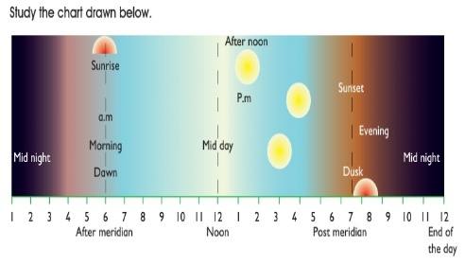  From From chart above;  Lets the pupils know that –  1. 12 midnight to 12 noon (midday) is known as ante meridian (a.m).  2. 12 noon (midday) to 12 midnight again is known as post – meridian (p.m).  Note – communicate the above in the language they will understand, preferably mother tongue. | Pupils study the chart, listen and ask questions if they don’t understand.  Teacher – pay attention to them both verbal and non – verbal. | A.m and p.m
Step 4  Development  (10 minutes) | Groups exercises –  Write out these times using a.m. or p.m.  1. The time when the school assembly begins at 7.30.  2. The time when the school closes at 2 o’clock.  3. The time when you have your dinner at 7 o’clock.  4. The time when you go to bed at 9 o’clock  5. The time when daddy comes back from work at 5 o’clock.  6. The time when we have break at 12.05.  7. Quarter past three in the morning.  8. Eighteen minutes to six in the evening.  9. Half past eleven in the morning.  10. Twenty minutes to three in the afternoon. | Group Activities | Conversion of unit of time
Step 5  Development  (10 minutes) | Asks each group to present their answers/results/solutions so that you can compare responses with those in other groups. | Presentation  8. P.m  9. A.m  10. P.m | Group Presentation
Step 6  Conclusion  (5 minutes) | To conclude the lesson, the teacher revises the entire lesson and ask the key questions.  Assignment  Copy and complete the following statements. The first one is done for you.  1. Four hours after midnight is 4 a.m  2. Three hours before midnight is.  3. Nine hours after midnight is.  4. Five hours after midday is.  5. Eleven hours after midday is.  6. Two hours before midday. | The learners listen, ask and answer questions. | Lesson Evaluation and Conclusion
PRIMARY 5
TOPIC: Plain Shapes - Parallel and Perpendicular Lines
LEARNING OUTCOME By the end of the lesson, pupils should be able to:
- identify parallel and perpendicular lines.
- state some properties of triangles.
- state some properties of quadrilateral.
- solve some quantitative aptitude problems.
RATIONALE Plane shapes in mathematics are any closed, flat, 2-dimensional shapes. They include triangle, quadrilateral and polygon. Plane shapes are made of straight lines, curved lines, or both straight and curved lines.
In this lesson, you will learn what plane shapes are and explore their different types and properties.
LEARNING MATERIALS The teacher will teach the lesson with the aid of 2 and 3 dimensional shapes. And Models of: equilateral, isosceles, right angled triangles.
PREVIOUS KNOWLEDGE
Plane shapes are all around us. These stop signs (all traffic signs are plane shapes), a sheet of paper, a paper plate, a stamp, etc. There are many kinds of plane shapes.
In this lesson, we will focus on 5 basic kinds: squares, rectangles, circles, triangles, and octagons
LESSON DEVELOPMENT ONE - PARALLEL AND PERPENDICULAR LINES

STAGE/TIME | TEACHER’S ACTIVITIES | LEARNER'S ACTIVITIES – MIND/HANDS ON | LEARNING POINTS
Step 1  Introduction  (5 minutes) | Presents chart of cuboid or cube and and the real object of cuboid or cube – carton.  ABCDEFGH is a cube placed on a table.  Guides and lets the pupils copy and complete these statements using the figure.  1. _____ and _____ are the horizontal faces.  2. The vertical faces are _____, _____, _____ and _____.  3. There are _____ horizontal edges.  4. There are _____ vertical edges. | 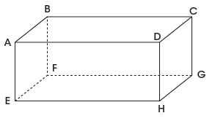  Results  1. ABCD and EFGH are horizontal faces.  2. ABEF, ADHE, CDHG, and BCFG are vertical faces.  3. 8 horizontal edges.  4. 16 vertical edges.  Note – each face has 4 edges. | Linking the Previous knowledge to the new lesson
Step 2  Development  (5 minutes)  Grouping | 1. Groups the learners into four groups – A, B, C, and D.  2. Guide the learners to choose a leader and secretary for your group.  3. Gives each group learning materials. – chart of parallel and perpendicular lines, 2 and 3 dimensional shapes. | 1. Belong to a group.  2. Choose their leader and secretary.  3. Received learning materials for their group. | Learner’s group, leader and secretary confirmed.
Step 3  Development  (5 minutes) | 1. Observe the lines drawn on the chart.  2. Use your ruler to measure the length between each line.  3. What do you observe?  Lets pupils know that the lines are called parallel lines. | 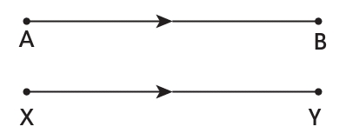  Measurements  AB _____ XY _____  Observations  The lines are equal lines. | Parallel Lines
Step 4  Development  (5 minutes) | 1. Observe the lines drawn on the chart.  2. What do you observe?  Yes, the lines are intercept and both are called perpendicular lines. | 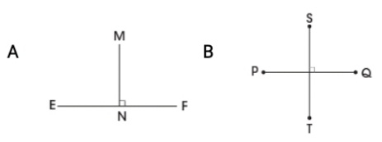  Observation  The lines are intercept. | Perpendicular Lines
Step 5  Development  (5 minutes) | Groups exercises –  1. Name a line parallel to AB.  2. Name a line parallel to GH.  3. Name two lines that are perpendicular to AB and pass through A.  4. Name two lines that are perpendicular to AB and pass through B. | Group Activities | Conversion of unit of time
Step 6  Development  (10 minutes) | Asks each group to present their results/solutions so that you can compare responses with those in other groups. | Presentation  1. EF  4. AE and AD | Group Presentation
Step 7  Conclusion  (5 minutes) | To conclude the lesson, the teacher revises the entire lesson and ask the key questions.  Assignment  Mention 5 parallel and perpendicular lines with their corresponding lines. | The learners listen, ask and answer questions. | Lesson Evaluation and Conclusion

LESSON DEVELOPMENT TWO - PROPERTIES OF TRIANGLES

STAGE/TIME | TEACHER’S ACTIVITIES | LEARNER'S ACTIVITIES – MIND/HANDS ON | LEARNING POINTS
Step 1  Introduction  (5 minutes) | Introductory Activities –  1. Draw a line.  2. Draw another line from the starting or end of the first line.  3. How many lines have you drawn?  4. Draw another line to join the first and second lines together.  5. How many lines altogether?  6. What do you observe?  7. What shape is this?  8. Triangle has many corners?  Note – Lets pupils know that the 3 corners of triangle is called vertices. | HANDS ON ACTIVITIES –  1.  2.  3. 3 lines.  4.  5. 3 lines.  6. Observation.  7. Triangle.  8. 3 corners. | Linking the Previous knowledge to the new lesson
Step 2  Development  (5 minutes)  Grouping | 1. Groups the learners into four groups – A, B, C, and D.  2. Guide the learners to choose a leader and secretary for your group.  3. Gives each group learning materials – chart and sample of triangles, 2 and 3 dimensional shapes. | 1. Belong to a group.  2. Choose their leader and secretary.  3. Received learning materials for their group. | Learner’s group, leader and secretary confirmed.
Step 3  Development  (5 minutes) | TRIANGLE  1. Name the 3 corners A, B and C.  Teacher’s comments – The triangle is called triangle ABC.  If the side between A and B is called AB.  The side between A and C is called AC.  2. Side between A and C, B and C are called _____________.  The angle at:  If corner A is called angle A or A, what is corner B and C? | 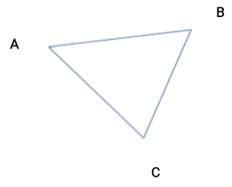  Listen to teacher’s comments.  2. Side between A and C is called AC.  Side between B and C is called BC.  3. Corner B is called angle B or B.  Corner C is called angle C or C. | Properties of Triangle
Step 4  Development  (5 minutes) | TYPES OF TRIANGLES  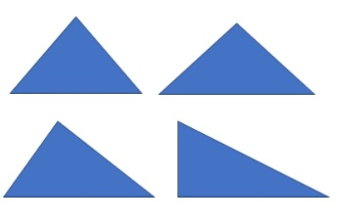  1. Study the chart.  2. Name the sides of each triangle ABC.  3. Measure AB, AC and BC of each triangle.  4. Record your measurements.  5. What is your observations. | Groups work  3/4. First triangle –  AB _______  AC _______  BC _______  Second triangle –  AB _______  AC _______  BC _______  Third triangle –  AB _______  AC _______  BC _______  5. Observations –  First triangle, all sides are equal.  Second triangle, 2 of its sides are equal.  Third triangle, no equal side. | Types of Triangle and their properties.
Step 5  Development  (10 minutes) | Asks each group to present their results/solutions so that you can compare responses with those in other groups. | Presentation | Group Presentation
Step 7  Conclusion  (5 minutes) | To conclude the lesson, the teacher revises the entire lesson and ask the key questions.  SUMMARY  First triangle is called equilateral triangle. Second triangle is called isosceles triangle while the third triangle is called scalene triangle. The fourth triangle is a right - angle triangle. One of its angles is at 90°.  Assignment  1. What is a triangle?  2. How many types of triangle do we have?  3. Name them.  4. What are the properties or characteristics of each types of triangle? | The learners listen, ask and answer questions. | Lesson Evaluation and Conclusion

LESSON DEVELOPMENT TWO - PROPERTIES OF QUADRILATERAL

STAGE/TIME | TEACHER’S ACTIVITIES | LEARNER'S ACTIVITIES – MIND/HANDS ON | LEARNING POINTS
Step 1  Introduction  (5 minutes) | Introductory Activities – Drawing four sided shape.  1. Draw a line.  2. Draw another line from the starting or end of the first line.  3. Draw another line from other end.  4. Draw one more to join the four lines together.  5. How many lines altogether?  6. What do you observe?  7. What shape is this?  8. This shape has many corners?  Note – Lets pupils know that the shape is called quadrilateral. | 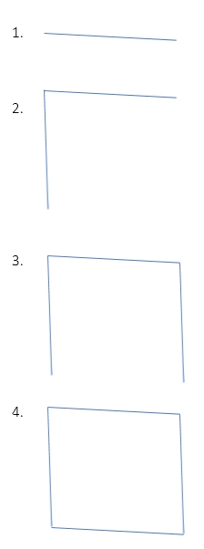  HANDS ON ACTIVITIES –  5. 4 lines.  6. Observing  7. A shape.  8. 4 corners. | Linking the Previous knowledge to the new lesson
Step 2  Development  (5 minutes)  Grouping | 1. Groups the learners into four groups – A, B, C, and D.  2. Guide the learners to choose a leader and secretary for your group.  3. Gives each group learning materials – chart and sample of different quadrilaterals (square and rectangle), 2 and 3 dimensional shapes. | 1. Belong to a group.  2. Choose their leader and secretary.  3. Received learning materials for their group. | Learner’s group, leader and secretary confirmed.
Step 3  Development  (5 minutes) | QUADRILATERALS  1. Name the 4 corners A, B, C and D.  If the side between A and B is called AB.  The side between A and C is called AC.  2. Side between A and C, B and C, C and D are called _____________.  The angle at:  If corner A is called angle A or A, what is corner B, C and D? | Listen to teacher’s comments.  2. Side between A and C is called AC.  Side between B and C is called BC.  Side between C and D is called CD.  3. Corner B is called angle B or B.  Corner C is called angle C or C.  Corner D is called angle D or D. | Properties of Quadrilateral
Step 4  Development  (5 minutes) | TYPES OF QUADRILATERAL  1. Study the chart.  2. Name the sides of each triangle ABCD.  3. Measure AB, AC, BC and CD of each quadrilateral.  4. Record your measurements.  5. What is your observations.  6. What are the names of these 2 shapes? | Groups work  3/4. First triangle –  AB _______  AC _______  BC _______  Second triangle –  AB _______  AC _______  BC _______  CD _______  5. Observations –  First triangle – all sides are equal.  Second triangle – out of 4 lines, 2 lines are equal and the 2 ramaining lines are equal too.  6…..? | Types of quadrilateral and their properties.
Step 5  Development  (10 minutes) | Asks each group to present their results/solutions so that you can compare responses with those in other groups. | Presentation | Group Presentation
Step 7  Conclusion  (5 minutes) | To conclude the lesson, the teacher revises the entire lesson and ask the key questions.  SUMMARY  The first and second shapes are square and rectangle. There are many types of quadrilateral. Other are trapezium, rhombus, kite, and parallelogram.  Assignment  Draw the following shapes –  1. Trapezium  2. Rhombus  3. Kite  4. Parallelogram | The learners listen, ask and answer questions. | Lesson Evaluation and Conclusion
PRIMARY 6
TOPIC: Angles (Measuring of Angles)
LEARNING AREA
LEARNING OUTCOME By the end of the lesson, pupils should be able to:
- measure angles in degrees using clock and protractor.
- measure angles in a plane.
- measure and draw angles using a protractor.
- identify the properties of angles formed by lines.
- identify the properties of angles formed by parallel lines and a transversal.
RATIONALE Angles are the space between two or more line that meet. If two lines meet (or intersect) at a point, then an angle is formed. The point of intersection of the lines is called the vertex. A protractor is used to measure angles.
Angles are used in daily life. Angles are used for designs, roads, buildings and sporting facilities by engineers and architects. Carpenter used to make chairs and tables. In this lesson, the pupils understand and appreciate the usefulness of angles in life.
LEARNING MATERIALS The teacher will teach the lesson with the aid of Mathematical set, Board, Board protractor and Ruler, Graph sheets.
PREVIOUS KNOWLEDGE The pupils are amazing. Some of them are on the path of becoming an artist, engineers, architect, etc. This is what most of them do after the school hours and holidays. The concept of angels will expose them to reality of the work are they currently learning.
LESSON DEVELOPMENT ONE - INTRODUCTION TO ANGLES

STAGE/TIME | TEACHER’S ACTIVITIES | LEARNER'S ACTIVITIES – MIND/HANDS ON | LEARNING POINTS
Step 1  Introduction  (5 minutes) | Introductory Activities –  1. Draw a straight line.  2. Draw another line from the starting or end of the first line.  Point to note for the pupils - The point of intersection of the lines is called the corner or vertex. | HANDS ON ACTIVITIES – | Linking the Previous knowledge to the new lesson
Step 2  Development  (5 minutes)  Grouping | 1. Groups the learners into four groups – A, B, C, and D.  2. Guide the learners to choose a leader and secretary for your group.  3. Gives each group learning materials – mathematical set and plain paper. | 1. Belong to a group.  2. Choose their leader and secretary.  3. Received learning materials for their group. | Learner’s group, leader and secretary confirmed.
Step 3  Development  (5 minutes) | ANGLES  Angles are the space between two or more line that meet. If two lines meet (or intersect) at a point, then an angle is formed.  Name the 3 points of the two lines A, B and C.  Lines AB and AC meet at the point A to form an angle.  The corner A is called angle. Written as ∠ BAC or ∠ CAB. | 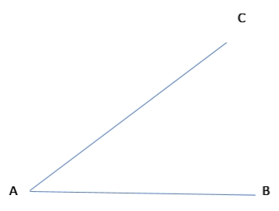 | Angle
Step 4  Development  (5 minutes) | TYPES OF ANGLES  Angles range from 0° to 360° are group into –  1. Acute angles – less than 90°.  2. A right angle – exactly 90°.  3. Obtuse angles – greater than 90° and less than 180°  4. Angle on a straight line – 180°  5. A reflex angle – greater than 180° but less than 360°  6. Full angle – exactly 360°. | Listen to teacher and give examples of –  1. Acute angles  2. Obtuse angles  3. Reflex angles.  Identify –  4. 90°  5. 180°  6. 360°. | Types of Triangle and their properties.
Step 5  Development  (5 minutes) | Exercises – group the following angles into acute, obtuse, reflex, right and full angles.  1. 62° 2. 53° 3. 141° 4. 90° 5. 65°  6. 127° 7. 40° 8. 136° 9. 270° 10. 360° | Groups Activities | Group work
Step 6  Development  (10 minutes) | Asks each group to present their results/solutions so that you can compare responses with those in other groups. | Presentation | Group Presentation
Step 7  Conclusion  (5 minutes) | To conclude the lesson, the teacher revises the entire lesson and ask the key questions.  KEY QUESTIONS  1. What is angle?  2. Mention the 6 types of Angles.  3. How does an angle formed? | The learners listen, ask and answer questions. | Lesson Evaluation and Conclusion

LESSON DEVELOPMENT TWO - MEASURING OF ANGLES

STAGE/TIME | TEACHER’S ACTIVITIES | LEARNER'S ACTIVITIES – MIND/HANDS ON | LEARNING POINTS
Step 1  Introduction  (5 minutes) | Introductory Activities –  1. What is this object called?  2. What is it used for?  3. How many hands does it has?  4. What is the different between both hands?  Point to note for the pupils – When two lines meet (or intersect) at a point, then an angle is formed.  The minutes and hour hands represent the two lines. The space between minute and hour hands make an angle. | 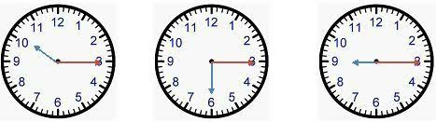  MIND ON ACTIVITIES –  1. Clock.  2. It is used for telling time.  3. It has two hands  4. The first hand is called hour hand, and it is short. The second hand is called minute hand, and it is long. | Linking the Previous knowledge to the new lesson
Step 2  Development  (5 minutes)  Grouping | 1. Groups the learners into four groups – A, B, C, and D.  2. Guide the learners to choose a leader and secretary for your group.  3. Gives each group learning materials – mathematical set, clock, chart of different angles and plain paper. | 1. Belong to a group.  2. Choose their leader and secretary.  3. Received learning materials for their group. | Learner’s group, leader and secretary confirmed.
Step 3  Development  (5 minutes) | Measuring of Angles using clock  1. Write the time shown on each clock face.  A Full Angle is an angle that has a measure of exactly 360°.  1 minute = 6°  2 minutes = 12°  60 minutes = 360°  2. Write the angles between minute and hour hands. | 1. 10:15  15 m = 15 x 6°  = 90°  2. 3:30  30 m = 30 x 15°  = 180°  3. 9:45  45 m = 45 x 6°  = 270° | Angles between minute and hour hands.
Step 4  Development  (10 minutes) | Measure the following angles using clock.  Guided instructions –  1. Draw 2 straight lines perpendicular to one another across the intersection.  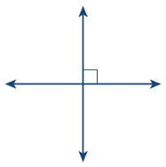  2. Draw a circle around the perpendicular lines.  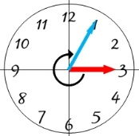  3. Number the circumference like the face of a clock.  4. Find the minutes and multiply by 6°. | Groups Activities  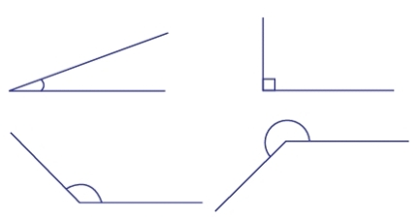 | Measurement of angles using clock.
Step 10  Development  (10 minutes) | Asks each group to present their results/solutions so that you can compare responses with those in other groups. | Presentation | Group Presentation
Step 6  Conclusion  (5 minutes) | To conclude the lesson, the teacher revises the entire lesson and ask the key questions.  SUMMARY | The learners listen, ask and answer questions. | Lesson Evaluation and Conclusion

LESSON DEVELOPMENT THREE - ANGLES ON A STRAIGHT LINE AND ANGLES AT A POINT

STAGE/TIME | TEACHER’S ACTIVITIES | LEARNER'S ACTIVITIES – MIND/HANDS ON | LEARNING POINTS
Step 1  Introduction  (5 minutes) | Introductory Activities – Guides the pupils to  1. Draw a straight line and name it line AB.  2. Place your protractor on the straight line.  3. Take your reading from A (at 0°) to B (at 180°).  4. What is angle on a straight line? | MIND ON ACTIVITIES –  A B  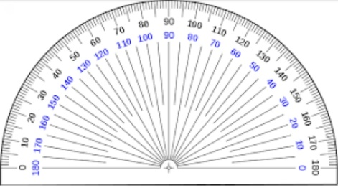  Angle on a straight line is 180°. | Linking the Previous knowledge to the new lesson
Step 2  Development  (5 minutes)  Grouping | 1. Groups the learners into four groups – A, B, C, and D.  2. Guide the learners to choose a leader and secretary for your group.  3. Gives each group learning materials – mathematical set, clock, chart of different angles and plain paper. | 1. Belong to a group.  2. Choose their leader and secretary.  3. Received learning materials for their group. | Learner’s group, leader and secretary confirmed.
Step 3  Development  (10 minutes) | 1. Draw two straight lines to intersect.  2. Name all the angles formed a, b, c and d respectively.  3. Use your protractor to measure each angle – guide them.  4. Add all the 4 angles together.  Point to know – angle on a straight line equal to 180°. Angles on 2 straight lines equal to 360°.  5. What are angles on the first and second straight lines?  6. Add together angles on each straight lines together.  Point to note - ∠ a and ∠ c are opposite each other. Likewise ∠ b and ∠ d are opposite each other. The two angles that are opposite each other are called vertically opposite angles. | 1. & 2.  a b  c d  3. Measurements –  ∠ a = ____,  ∠ b = ____,  ∠ c = ____, and  ∠ d = ____.  4. ∠ a + ∠ b + ∠ c + ∠ d = 360°  5. 1st line, ∠ a and ∠ b. 2nd line ∠ c and ∠ d.  6. 1st line, ∠ a + ∠ b = 180°.  2nd line, ∠ c + ∠ d = 180 °. | Measuring of Angles using protractor.
Step 4  Development  (10 minutes) | Calculate the size of each marked angle. | 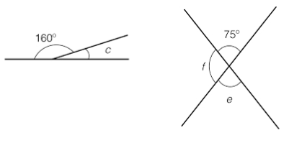  Groups Activities | Measurement of angles using clock.
Step 10  Development  (10 minutes) | Asks each group to present their results/solutions so that you can compare responses with those in other groups. | Presentation  1. Angles on a straight line is 180°.  Therefore, 160° + c = 180°  c = 180° - 160° = 20° | Group Presentation
Step 6  Conclusion  (5 minutes) | To conclude the lesson, the teacher revises the entire lesson and ask the key questions.  KEY QUESTIONS  1. What is the different between angles on a straight line and angles at a point.  2. The two angles that are opposite each other are called ___________  (a) vertically opposite  (b) horizontally opposite  (c) adjacent  ASSIGNMENT  3. Calculate angle ∠ m.  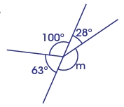 | The learners listen, ask and answer questions. | Lesson Evaluation and Conclusion

LESSON DEVELOPMENT FOUR - SUM OF ANGLES IN TRIANGLES

STAGE/TIME | TEACHER’S ACTIVITIES | LEARNER'S ACTIVITIES – MIND/HANDS ON | LEARNING POINTS
Step 1  Introduction  (5 minutes) | Introductory Activities –  1. Draw a line.  2. Draw another line from the starting or end of the first line.  3. How many lines have you drawn?  4. Draw another line to join the first and second lines together.  5. How many lines altogether?  6. What do you observe?  7. What shape is this?  8. Triangle has many corners?  Note – Lets pupils know that the 3 corners of triangle is called vertices. | HANDS ON ACTIVITIES –  1.  2.  3. 3 lines.  4.  5. 3 lines.  6. Observation.  7. Triangle.  8. 3 corners. | Linking the Previous knowledge to the new lesson
Step 2  Development  (5 minutes)  Grouping | 1. Groups the learners into four groups – A, B, C, and D.  2. Guide the learners to choose a leader and secretary for your group.  3. Gives each group learning materials – chart and sample of triangles, 2 and 3 dimensional shapes. | 1. Belong to a group.  2. Choose their leader and secretary.  3. Received learning materials for their group. | Learner’s group, leader and secretary confirmed.
Step 3  Development  (5 minutes)  If the side between A and B is called AB.  If corner A is called angle A or ∠ A. | TRIANGLE  1. Name the 3 corners A, B and C.  Teacher’s comments – The triangle is called triangle ABC.  2. The side between A and C is called AC. Side between B and C are called _____________.  The angle at:  What is corner B and C?  Point to note – angle A is written as ∠ BAC or CAB.  4. How is angles B and C are written? | Listen to teacher’s comments.  2. Side between B and C is called BC.  3. Corner B is called angle B or ∠ B.  Corner C is called angle C or ∠ C.  4. Angle B is written as ∠ ABC or CBA. While angle C is written as ∠ ACB or BCA. | Properties of Angle
Step 4  Development  (10 minutes) | Measuring Angles in a Triangle  1. Study and Name each triangle ABC, then easure the angles following triangles –  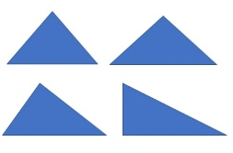  2. Record your measurements.  3. Add all the 3 angles in a triangle together.  4. Observe and record your observations. | Groups Activities –  1st, 2nd, & 3rd Instructions Studying and recording –  First triangle,  ∠ A = _____  ∠ B = _____  ∠ C = _____  Sum of angles = _____  Second triangle,  ∠ A = _____  ∠ B = _____  ∠ C = _____  Sum of angles = _____  Third triangle,  ∠ A = _____  ∠ B = _____  ∠ C = _____  Sum of angles = _____  Fourth triangle,  ∠ A = _____  ∠ B = _____  ∠ C = _____  Sum of angles = _____  4. Observation | Sum of Angles in a Triangle.
Step 5  Development  (10 minutes) | Asks each group to present their results/solutions so that you can compare responses with those in other groups. | Presentation  First triangle,  ∠ A = 60°  ∠ B = 60°  ∠ C = 60°  Sum of angles  = 60° + 60° + 60° = 180° | Group Presentation
Step 7  Conclusion  (5 minutes) | To conclude the lesson, the teacher revises the entire lesson and ask the key questions.  SUMMARY  The sum of angles in a triangle is 180°.  ASSIGNMENT  Find the missing angle in each of the following: | The learners listen, ask and answer questions.  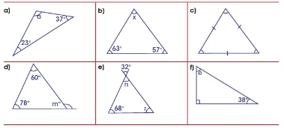 | Lesson Evaluation and Conclusion

