LESSON DEVELOPMENT TWO

IDENTIFICATION OF COMMON ICT GADGETS – ANALOG AND DIGITAL ICT

STAGE/TIME | TEACHER’S ACTIVITIES | LEARNER'S ACTIVITIES – MIND/HANDS ON | LEARNING POINTS
Step 1  Introduction  (5 minutes) | Guides pupils –  1. Study the chart carefully.  2. Tell the time on the clocks.  3. Describe the different between both clocks. | 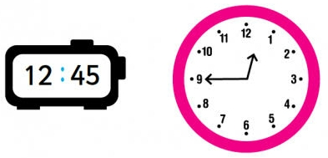 | Linking the Previous knowledge to the new lesson
Step 2  Development  (5 minutes)  Grouping | 1. Groups the learners into four groups – A, B, C, and D.  2. Guide the learners to choose a leader and secretary for your group.  3. Gives each group learning materials. – Charts/sample of analog and digital ICT. | 1. Belong to a group.  2. Choose their leader and secretary.  3. Received learning materials for their group. | Learner’s group, leader and secretary confirmed.
Step 3  Development  (5 minutes) | Lets the pupils that the first clock is called as digital ICT and the second is analog.  Study the chart carefully. | 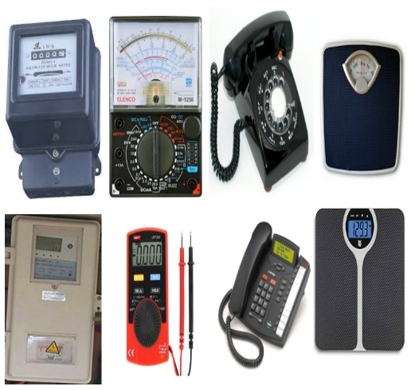  Listen to teacher’s comments. | Analog and Digital ICT
Step 4  Development  (10 minutes) | Group Instructions  Identify, name and group the ICT gadgets into analog and digital ICT.  Describe how each gadget and its corresponding gadget works. | Groups Activities | Groups work
Step 4  Development  (10 minutes) | Asks each group to present their answers so that you can compare responses with those of other groups. | Presentation | Presentation
Step 5  Conclusion  (5 minutes) | To conclude the lesson, the teacher revises the entire lesson and ask the key questions.  SUMMARY –  Examples of analog ICT are table phone, meter, technician meter, etc. as shown on the chart.  Examples of digital ICT are prepaid meter, technician reading meter, measuring scale, etc. as shown on the chart.  KEY QUESTIONS – ASSIGNMENT  Draw the picture of any two analog ICT with its corresponding digital ICT. | The learners listen, ask and answer questions. | Lesson Evaluation and Conclusion

