LESSON DEVELOPMENT THREE

IDENTIFICATION OF COMMON ICT GADGETS – USES OF ICT GADGETS

STAGE/TIME | TEACHER’S ACTIVITIES | LEARNER'S ACTIVITIES – MIND/HANDS ON | LEARNING POINTS
Step 1  Introduction  (5 minutes) | Asks pupils to differentiate between the following analog and digital ICT –  1. Clock  2. Phone  3. Electricity meter  4. Measuring scale | The different between analog and digital ICT – clock.  On the analog clock, the time is represented by hands that spin around a dial and point to a location on the dial that represents the approximate time.  On a digital clock, a numeric display indicates the exact time. | Linking the Previous knowledge to the new lesson
Step 2  Development  (5 minutes)  Grouping | 1. Groups the learners into four groups – A, B, C, and D.  2. Guide the learners to choose a leader and secretary for your group.  3. Gives each group learning materials. – Charts/sample of ICT gadgets. | 1. Belong to a group.  2. Choose their leader and secretary.  3. Received learning materials for their group. | Learner’s group, leader and secretary confirmed.
Step 3  Development  (5 minutes) | Lets pupils identify the following ICT gadgets on the chart. | 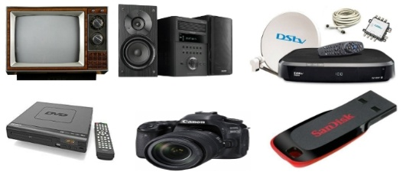  Television, Radio player, Dstv dish, Dstv decoder, DVD player, camera and flash drive. | Analog and Digital ICT
Step 4  Development  (10 minutes) | Group Instructions  State 2 uses of the following ICT gadgets on chart. | Groups Activities | Groups work
Step 4  Development  (10 minutes) | Asks each group to present their answers so that you can compare responses with those of other groups. | Presentation | Presentation
Step 5  Conclusion  (5 minutes) | To conclude the lesson, the teacher revises the entire lesson and ask the key questions.  SUMMARY - A gadget is a small machine or tool specially designed to do a definite piece of work. Many of the gadgets which we use for dealing with information and communication today use the digital system.  KEY QUESTIONS – ASSIGNMENT  State 2 uses of mobile phone, computer, printer, scanner, microphone, memory card, Ps game and headphone. | The learners listen, ask and answer questions. | Lesson Evaluation and Conclusion

