LESSON DEVELOPMENT TWO

IMPORTANCE OF MAINTENANCE

STAGE/TIME | TEACHER’S ACTIVITIES | LEARNER'S ACTIVITIES – MIND/HANDS ON | LEARNING POINTS
Step 1  Introduction  (5 minutes) | State the reason why a product like generator, television, radio, fan, car, tools, equipment, etc. doesn’t last long. | Lack of maintenance, not following manufacturer instructions, not handling with care, etc. | Linking the Previous knowledge to the new lesson
Step 2  Development  (5 minutes)  Grouping | 1. Groups the learners into four groups – A, B, C, and D.  2. Guide the learners to choose a leader and secretary for your group.  3. Gives each group learning materials – chart showing before and after maintenance. | 1. Belong to a group.  2. Choose their leader and secretary.  3. Received learning materials for their group. | Learner’s group, leader and secretary confirmed.
Step 3  Development  (10 minutes) | Asks pupils to study the chart carefully.  Tells them to state 5 importance of maintenance. | 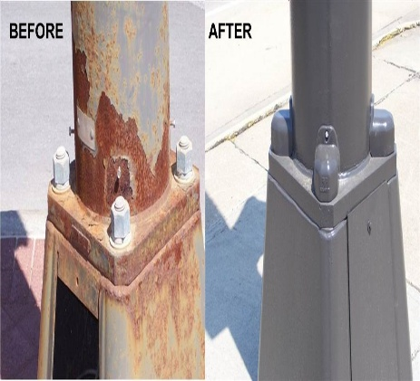 | Group work
Step 4  Development  (10 minutes) | Asks each group to present their answers so that you can compare responses with those of other groups. | Presentation – | Presentation
Step 5  Conclusion  (5 minutes) | To conclude the lesson, the teacher revises the entire lesson and ask the key questions.  KEY QUESTIONS – State 5 important of maintenance. | The learners listen, ask and answer questions.  Importance of Maintenance  1. Prevents metals from rusting.  2. Makes tools and equipment last longer.  3. Prevents us from danger.  4. Prevents embarrassing situations.  5. Prevents waste.  6. Saves cost. | Lesson Evaluation and Conclusion

