LESSON DEVELOPMENT ONE

INTRODUCTION TO MAINTENANCE

STAGE/TIME | TEACHER’S ACTIVITIES | LEARNER'S ACTIVITIES – MIND/HANDS ON | LEARNING POINTS
Step 1  Introduction  (5 minutes) | Gets any rusted metallic objects like pins, padlock, tools, etc.  Lets pupils discuss the reasons why these objects are rusted.  State ways of preventing such objects from rusting again. | 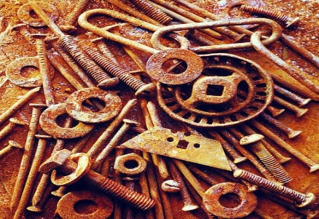  Point for the pupils to know - Tells them that the process of preventing an object from getting worst or damaged is called maintenance. | Linking the Previous knowledge to the new lesson
Step 2  Development  (5 minutes)  Grouping | 1. Groups the learners into four groups – A, B, C, and D.  2. Guide the learners to choose a leader and secretary for your group.  3. Gives each group learning materials. – chart/sample of rusted metallic and dirty containers. | 1. Belong to a group.  2. Choose their leader and secretary.  3. Received learning materials for their group. | Learner’s group, leader and secretary confirmed.
Step 3  Development  (10 minutes) | Lets the pupils study the chart carefully.  Describe various activities. | 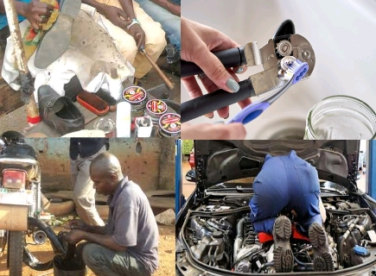 | Group work
Step 4  Development  (10 minutes) | Asks each group to present their answers so that you can compare responses with those of other groups. | Presentation | Presentation
Step 5  Conclusion  (5 minutes) | To conclude the lesson, the teacher revises the entire lesson and ask the key questions.  KEY QUESTIONS – What is What is maintenance? | The learners listen, ask and answer questions.  Maintenance is an activities that should be carried out on daily basis in order to keep equipment in good working condition. | Lesson Evaluation and Conclusion

