LESSON DEVELOPMENT FOUR

AREA OF SQUARE AND RECTANGLE

STAGE/TIME | TEACHER’S ACTIVITIES | LEARNER'S ACTIVITIES – MIND/HANDS ON | LEARNING POINTS
Step 1  Introduction  (5 minutes) | Introductory Activities – asks pupils to:  Lets pupils count all the squares in each shape.  Point for the pupils – Counting the squares is not a very efficient way to determine the area.  There is a better way. | 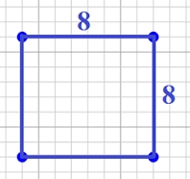  HANDS ON ACTIVITIES –  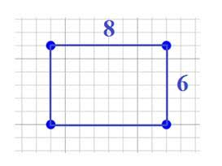  Square – 64  Rectangle - 48 | Linking the Previous knowledge to the new lesson
Step 2  Development  (5 minutes)  Grouping | 1. Groups the learners into four groups – A, B, C, and D.  2. Guide the learners to choose a leader and secretary for your group.  3. Gives each group learning materials – chart showing a square and rectangle. | 1. Belong to a group.  2. Choose their leader and secretary.  3. Received learning materials for their group. | Learner’s group, leader and secretary confirmed.
Step 3  Development  (5 minutes) | Guides pupils to count the number of small squares on the row and column.  Rectangle  Row _____ / Column _____.  Square  Row _____ / Column _____.  Area of square and rectangle is A = Length ( l ) x Breadth ( b), that’s L x B.  Lets pupils know that the row is the length and the column is the breadth. | Rectangle  Row 6 / Column 4  Square  Row 6 / Column 6  Area of rectangle = 6 x 4 = 24  Area of square = 6 x 6 = 36 | Area (A) = Length (L) x Breadth (B)
Step 4  Development  (10 minutes) | Pupil’s Activities  Find the length and breadth of the following shapes.  Find the areas of square and rectangle. | 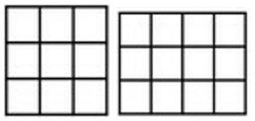  Groups Activities
Step 5  Development  (10 minutes) | Asks each group to present their results/solutions so that you can compare responses with those in other groups. | Presentation | Group Presentation
Step 6  Conclusion  (5 minutes) | To conclude the lesson, the teacher revises the entire lesson and ask the key questions.  KEY QUESTIONS – QUANTITATIVE  [ L ] × [ B ] = [ A ]  1. [ 4 ] x [ 4 ] = [ ]  2. [ 5 ] x [ ] = [ 30 ]  3. [ ] x [ 8 ] [ 24 ]  4. [ 6 ] x [ ] = [ 36 ] | The learners listen, ask and answer questions.  SOLUTION  1. [ 4 ] x [ 4 ] = [ 16 ] | Lesson Evaluation and Conclusion

Reference book – New Method Mathematics Book 4.

