LESSON DEVELOPMENT ONE

PROPERTIES OF SQUARE

STAGE/TIME | TEACHER’S ACTIVITIES | LEARNER'S ACTIVITIES – MIND/HANDS ON | LEARNING POINTS
Step 1  Introduction  (5 minutes) | Introductory Activities – Drawing four sided shape.  1. Draw a line.  2. Draw another line from the starting or end of the first line.  3. Draw another line from other end.  4. Draw one more to join the four lines together.  Note – Lets pupils know that the shape is called quadrilateral. | 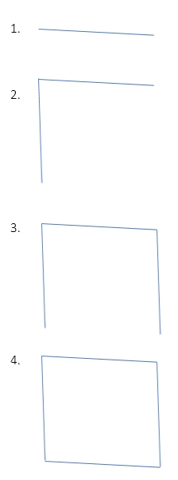  HANDS ON ACTIVITIES –  5. 4 lines.  6. A shape. | Linking the Previous knowledge to the new lesson
Step 2  Development  (5 minutes)  Grouping | 1. Groups the learners into four groups – A, B, C, and D.  2. Guide the learners to choose a leader and secretary for your group.  3. Gives each group learning materials – pencil, ruler, drawing book, chart of square. | 1. Belong to a group.  2. Choose their leader and secretary.  3. Received learning materials for their group. | Learner’s group, leader and secretary confirmed.
Step 3  Development  (5 minutes) | Lets pupils know that there are different types of quadrilateral –  square, rectangle, parallelogram, trapezium, rhombus and kite. They have similar properties but they are not the same.  Ask pupils –  1. How many lines formed a quadrilateral?  2. How many corners? | Listen to teacher’s explanation.  1. 4 lines.  2. 4 corners. | Properties of Quadrilateral
Step 4  Development  (10 minutes)  Note for the pupils after the all activities, the shape is called a square. | Activities for the pupils –  1. How many lines formed this shape.  2. Measure each of the lines.  3. What do you observe?  4. How many corners the shape has? |  | Properties of square
Step 5  Development  (10 minutes) | Asks each group to present their results/solutions so that you can compare responses with those in other groups. | Presentation –  1. 4 lines.  2. ____ cm each.  3. Equal lines  4. 4 corners. | Group Presentation
Step 6  Conclusion  (5 minutes) | To conclude the lesson, the teacher revises the entire lesson and ask the key questions.  KEY QUESTIONS –  1. What is a square?  2. State 2 properties of a square.  3. Gives 2 examples of square shape. | The learners listen, ask and answer questions.  1. Square is a shape that has 4 equal lines.  2. It has 4 lines. The lines are equal.  3. Cube of sugar, clock and dice, etc. | Lesson Evaluation and Conclusion

Reference book – New Method Mathematics Book 4.

