LESSON DEVELOPMENT THREE

PROPERTIES OF KITE AND RHOMBUS

STAGE/TIME | TEACHER’S ACTIVITIES | LEARNER'S ACTIVITIES – MIND/HANDS ON | LEARNING POINTS
Step 1  Introduction  (5 minutes) | Introductory Activities –  Asks pupils to study the chart carefully.  Tells them to compare the real objects with the plane shapes.  Listen to the pupils comparison. | MIND ON ACTIVITIES –  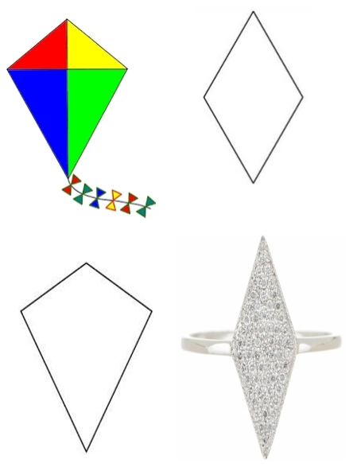 | Linking the Previous knowledge to the new lesson
Step 2  Development  (5 minutes)  Grouping | 1. Groups the learners into four groups – A, B, C, and D.  2. Guide the learners to choose a leader and secretary for your group.  3. Gives each group learning materials – chart and sample of different quadrilaterals – kite and rhombus. | 1. Belong to a group.  2. Choose their leader and secretary.  3. Received learning materials for their group. | Learner’s group, leader and secretary confirmed.
Step 3  Development  (5 minutes) | Lets the pupils identify the above shape.  Tells them the first shape is kite and the second shape (ring) is rhombus. | Kite and a ring.  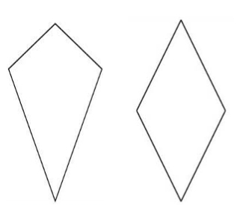 | Kite and Rhombus
Step 4  Development  (10 minutes) | Instructions  Asks pupils to name the shape ABCD and IJKL.  Lets them measure line AB, BC, DC and AD. Also, measure IJ, JK, KL and LI.  Compare line AB and AD; BC and DC. Also, compare IJ, JK, KL and LI.  Asks them to draw a straight line to connect the opposite corners. | Groups work  Properties of Kite and Rhombus  1. AB = _____, BC = _____, DC = _____ and AD = _____.  IJ = _____, JK = _____, KL = _____ and LI = _____.  2. AB = AD and BC = DC.  IJ = JK = KL = LI.  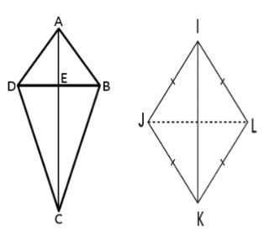  3. | Properties of Kite and Rhombus.
Step 5  Development  (10 minutes) | Asks each group to present their results/solutions so that you can compare responses with those in other groups. | Presentation | Group Presentation
Step 7  Conclusion  (5 minutes) | To conclude the lesson, the teacher revises the entire lesson and ask the key questions.  SUMMARY – kite is a quadrilateral with 2 sets of adjacent lines equal.  Rhombus is a quadrilateral with 4 equal  lines and its opposite lines are parallel.  KEY QUESTIONS – ASSIGNMENT  State 4 properties of kite and rhombus.  Give 4 shapes of kite and rhombus. | The learners listen, ask and answer questions. | Lesson Evaluation and Conclusion

Reference book – New Method Mathematics Book

