LESSON DEVELOPMENT ONE

PROPERTIES OF TRAPEZIUM

STAGE/TIME | TEACHER’S ACTIVITIES | LEARNER'S ACTIVITIES – MIND/HANDS ON | LEARNING POINTS
Step 1  Introduction  (5 minutes)  Note – Lets pupils know that the shape is called quadrilateral. | Introductory Activities – Drawing four sided shape.  1. Draw a line.  2. Draw another line from the starting or end of the first line.  3. Draw another line from other end.  4. Draw one more to join the four lines together.  5. How many lines altogether?  6. This shape has many corners?  7. Describe the shape as 4 sided shape. | 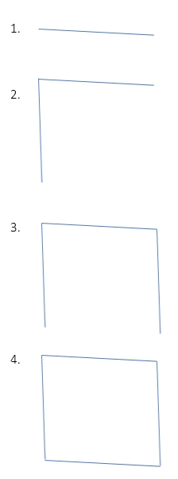  HANDS ON ACTIVITIES –  5. 4 lines.  6. 4 corners.  7. _____________ | Linking the Previous knowledge to the new lesson
Step 2  Development  (5 minutes)  Grouping | 1. Groups the learners into four groups – A, B, C, and D.  2. Guide the learners to choose a leader and secretary for your group.  3. Gives each group learning materials – chart and sample of different quadrilaterals – Trapezium. | 1. Belong to a group.  2. Choose their leader and secretary.  3. Received learning materials for their group. | Learner’s group, leader and secretary confirmed.
Step 3  Development  (5 minutes) | Lets pupils know that there are different types of quadrilateral – square, rectangle, parallelogram, TRAPEZIUM, rhombus and kite. They have similar properties (such as four sides and angles) but they are not the same.  Displays a chart of trapeziums and lets pupils compare the chart with their 4 sided shape.  Checks if any pupil has a similar and tells them – this shape is called trapezium. | Listen to teacher’s comments.  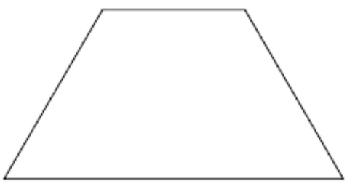  Point for pupils – tells them not to clean or change the shape they drawn in step 1 because it might be the next needed shape. | Trapezium
Step 4  Development  (10 minutes) | Instructions  1. Name the four corners of the shape - ABCD.  Question – Line AD and BC are called ___________?  2. Measure line AB, BC, CD and AD.  Question – Compare each line with another, is your measurements equal or different?  3. What is the space between two lines?  4. In how ways can this trapezium be divided. | Groups work  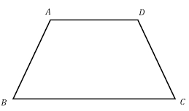  Point for pupils – line of symmetry divide a shape into equal parts. | Properties of Trapezium
Step 5  Development  (10 minutes) | Asks each group to present their results/solutions so that you can compare responses with those in other groups. | Presentation  1. Parallel lines  2. The lines are not equal.  3. It is called an angle.  4. It can not be divided equally. | Group Presentation
Step 7  Conclusion  (5 minutes) | To conclude the lesson, the teacher revises the entire lesson and ask the key questions.  SUMMARY – Trapezium is a quadrilateral with one pair of sides parallel.  KEY QUESTIONS – State 4 properties of trapezium. | The learners listen, ask and answer questions.  Properties of Trapezium  1. It has one pair of parallel sides.  2. The sides are not equal.  3. The angles are not equal.  4. It has no line of symmetry. | Lesson Evaluation and Conclusion

Reference book – New Method Mathematics Book 5.

