LESSON DEVELOPMENT THREE

MEASURING AND DRAWING OF ANGLES

STAGE/TIME | TEACHER’S ACTIVITIES | LEARNER'S ACTIVITIES – MIND/HANDS ON | LEARNING POINTS
Step 1  Introduction  (5 minutes) | INTRODUCTORY ACTIVITIES –  Asks pupils to describe the following angles –  1. Acute angles  2. Right angle  3. Obtuse angles  4. Angles on a straight line  5. Reflex angles  6. Full angle or angle at a point. | MIND ON ACTIVITIES –  1. < 90°  2. = 90°  3. > 90° and < 180°  4. = 180°  5. > 180° and < 360°  6. = 360° | Linking the Previous knowledge to the new lesson
Step 2  Development  (5 minutes)  Grouping | 1. Groups the learners into four groups – A, B, C, and D.  2. Guide the learners to choose a leader and secretary for your group.  3. Gives each group learning materials – mathematical set, clock, chart of different angles and plain paper. | 1. Belong to a group.  2. Choose their leader and secretary.  3. Received learning materials for their group. | Learner’s group, leader and secretary confirmed.
Step 3  Development  (5 minutes) | GUIDED INSTRUCTIONS – pupil’s activities.  1. Draw angle 120°, 60° and 30°.  2. Add angle 60° and 30°.  3. Add angle 120° and 60° together.  4. What type of angles is your results?  Note for the pupils – when you add 2 angles together and the result is 90° or 120°, it is called complementary or supplementary angle. | 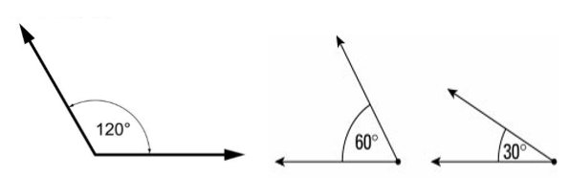  HANDS ON ACTIVITIES  60° + 30° = 90°  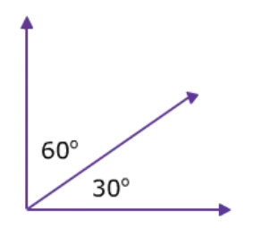  120° + 60° = 180°  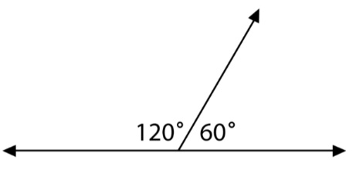  Angle 90° is a right angle while 180° is an angle on a straight line. | Complementary and supplementary angles
Step 4  Development  (10 minutes) | Calculate the size of the angle marked with a letter –  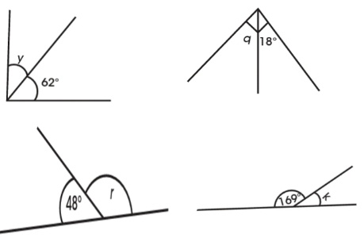 | Groups work | Complementary and supplementary angles
Step 10  Development  (10 minutes) | Asks each group to present their results/solutions so that you can compare responses with those in other groups. | Presentation | Group Presentation
Step 6  Conclusion  (5 minutes) | To conclude the lesson, the teacher revises the entire lesson and ask the key questions.  SUMMARY – Complementary angles are two angles that have a sum of 90°. Supplementary angles are two angles that have a sum of 180°.  KEY QUESTIONS (ASSIGNMENT) – Give the complement and supplementary of each of the following angles.  1. 51°  2. 13°  3. 46°  4. 65° | The learners listen, ask and answer questions. | Lesson Evaluation and Conclusion

Reference book – New Method Mathematics Book 5.

