LESSON DEVELOPMENT TWO
MEASURING AND DRAWING OF ANGLES
STAGE/TIME | TEACHER’S ACTIVITIES | LEARNER'S ACTIVITIES – MIND/HANDS ON | LEARNING POINTS
Step 1  Introduction  (5 minutes) | Introductory Activities –  Guides pupils to draw a circle with a perpendicular lines.  Lets them number the circle from 1 to 12 around the circle like that of a clock.  Point for the pupils - Clock is one of the ways an angle can be measured and drawn. | HANDS ON ACTIVITIES –  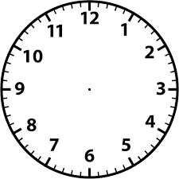 | Linking the Previous knowledge to the new lesson
Step 2  Development  (5 minutes)  Grouping | 1. Groups the learners into four groups – A, B, C, and D.  2. Guide the learners to choose a leader and secretary for your group.  3. Gives each group learning materials – mathematical set, clock, chart of different angles and plain paper. | 1. Belong to a group.  2. Choose their leader and secretary.  3. Received learning materials for their group. | Learner’s group, leader and secretary confirmed.
Step 3  Development  (5 minutes) | Guided Instructions – pupil’s activities.  1. Draw a straight line AB.  2. Place a dot at B. This dot represents the vertex or corner of the angle.  3. Place the centre of the protractor at B and the baseline of the protractor along the arm BA.  4. Find 60º on the scale and mark a small dot at the edge of the protractor.  5. Join the vertex to the small dot with a ruler to form the second arm, BC, of the angle.  6. Mark the angle with a small arc. | HANDS ON ACTIVITIES  Point for the pupils – A protractor is used in measuring and drawing angles. The image pictured is called a protractor. It has two scales, an inside and an outside scale. Both scales coincide at angle 90º.  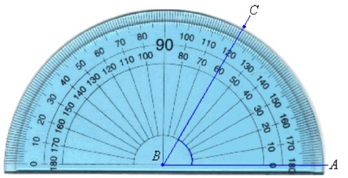  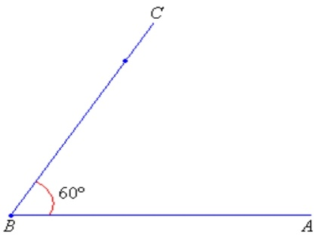 | Drawing angles.
Step 4  Development  (10 minutes) | 1. Place the midpoint of the protractor on the VERTEX of the angle.  2. Line up one side of the angle with the zero line of the protractor (where you see the number 0).  3. Read the degrees where the other side crosses the number scale.  Note for the pupils - A protractor has two sets of numbers: one set goes from 0 to 180, the other set from 180 to 0. Which one you read depends on how you place the protractor: place it so that one side of the angle lines up with one of the zeros, and read that set of numbers. | Groups work – Measure the following angles using your own protractor.  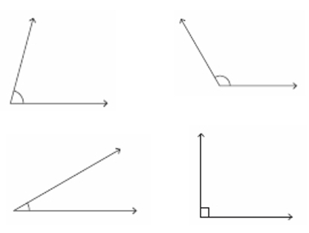 | Measuring angles
Step 10  Development  (10 minutes) | Asks each group to present their results/solutions so that you can compare responses with those in other groups. | Presentation | Group Presentation
Step 6  Conclusion  (5 minutes) | To conclude the lesson, the teacher revises the entire lesson and ask the key questions.  KEY QUESTIONS (ASSIGNMENT) –  Use your protractor to draw the following angles.  1. 25°  2. 47°  3. 65°  4. 160°  5. 73° | The learners listen, ask and answer questions. | Lesson Evaluation and Conclusion

Reference book – New Method Mathematics Book 5.

