LESSON DEVELOPMENT ONE

INTRODUCTION TO 3 DIMENSIONAL SHAPES

STAGE/TIME | TEACHER’S ACTIVITIES | LEARNER'S ACTIVITIES – MIND/HANDS ON | LEARNING POINTS
Step 1  Introduction  (5 minutes) | INTRODUCTORY ACTIVITIES – Pupil’s Activities  Asks pupils to match the face of 2 dimensional shapes with 3 dimensional shapes.  Lets them describe and compare 2 and 3 dimensional shapes.  Guides them to identify triangle with pyramid, square and rectangle with cuboid and triangle with prism. | MIND ON ACTIVITIES –  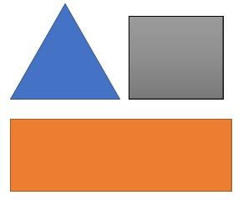  2 – Dimensional Shapes  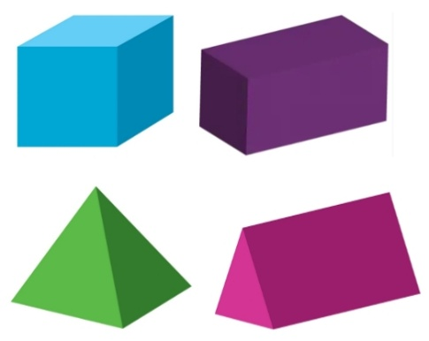  3 – Dimensional Shapes | Linking the Previous knowledge to the new lesson
Step 2  Development  (5 minutes)  Grouping | 1. Groups the learners into four groups – A, B, C, and D.  2. Guide the learners to choose a leader and secretary for your group.  3. Gives each group learning materials – sample of cube, cuboid, pyramid and prism (real and constructed objects). Chart showing examples of cubes, cuboids, pyramids and prisms. | 1. Belong to a group.  2. Choose their leader and secretary.  3. Received learning materials for their group. | Learner’s group, leader and secretary confirmed.
Step 3  Development  (5 minutes) | GENERAL ACTIVITIES – Pupil’s Activities  Guides pupils to identify 3 Dimensional Shapes – Cube, Cuboid, Pyramid and Prism.  Asks them to match the real objects with appropriate 3 – Dimensional and. | 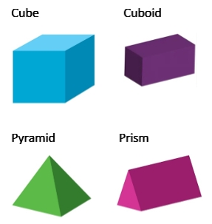  MIND ON ACTIVITIES  Cube – Cube sugar, Maggi cube and Ludo dice.  Cuboid - Brick, box of chalk and cartoon of detergents.  Pyramid – Pyramid of ground.  Prism – Building roof. | 3 – Dimensional Shapes with real life objects
Step 4  Development  (10 minutes) | GROUPS ACTIVITIES – INSTRUCTIONS  Copy and complete this table:  Solid shapes Faces Edges Vertices/ Corners  Cube  Cuboid  Pyramid  Prism | GROUPS WORK  Guides pupils to recall meaning of faces, edges and vertices. | Properties of 3 – Dimensional Shapes – Cube, Cuboid, Pyramid and Prism
Step 10  Development  (10 minutes) | Asks each group to present their results/solutions so that you can compare responses with those in other groups. | Presentation | Group Presentation
Step 6  Conclusion  (5 minutes) | To conclude the lesson, the teacher revises the entire lesson and ask the key questions.  SUMMARY – 3 Dimensional Shapes is a solid shape with length, breadth (width) and heights.  KEY QUESTIONS (ASSIGNMENT) – QUANTITATIVE  New Method Mathematics Book 6, page 239, exercise number 7. | The learners listen, ask and answer questions. | Lesson Evaluation and Conclusion

Reference book – New Method Mathematics Book 5.

