LESSON DEVELOPMENT THREE

NETS OF PYRAMIDS

STAGE/TIME | TEACHER’S ACTIVITIES | LEARNER'S ACTIVITIES – MIND/HANDS ON | LEARNING POINTS
Step 1  Introduction  (5 minutes) | INTRODUCTORY ACTIVITIES –  Gives 2 sample of different pyramids.  Asks pupils to compare and describe the different between the 2 pyramids. | MIND ON ACTIVITIES –  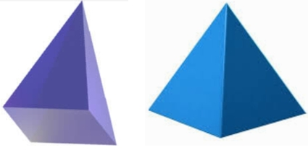  The first pyramid has triangular faces with square base while the second has triangular faces with triangular base. | Linking the Previous knowledge to the new lesson
Step 2  Development  (5 minutes)  Grouping | 1. Groups the learners into four groups – A, B, C, and D.  2. Guide the learners to choose a leader and secretary for your group.  3. Gives each group learning materials – chart showing different nets of pyramids. Nets sample of pyramids. | 1. Belong to a group.  2. Choose their leader and secretary.  3. Received learning materials for their group. | Learner’s group, leader and secretary confirmed.
Step 3  Development  (5 minutes) | GENERAL ACTIVITIES – Pupil’s Activities  Guides pupils to properly open the joints of these pyramids. | 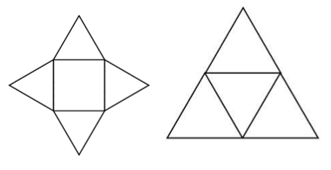  HANDS ON ACTIVITIES | Nets of triangular and square pyramids
Step 4  Development  (10 minutes) | GROUPS ACTIVITIES – INSTRUCTIONS  1. Make nets of triangular and square pyramids.  2. Cut the nets.  3. Fold the nets into triangular and square pyramids. | GROUPS WORK | Making of triangular and square pyramids
Step 10  Development  (10 minutes) | Asks each group to present their results/solutions so that you can compare responses with those in other groups. | Presentation | Group Presentation
Step 6  Conclusion  (5 minutes) | To conclude the lesson, the teacher revises the entire lesson and ask the key questions.  SUMMARY – A net is a two-dimensional figure that can be folded into a three-dimensional object.  KEY QUESTIONS (ASSIGNMENT) – Use the nets of these shapes you have made to answer questions 1 to 7.  1. A triangular-based pyramid has _____ triangular faces.  2. A triangular-based pyramid has _____ vertices.  3. A triangular-based pyramid has _____ edges.  4. A square-based pyramid has _____ square faces.  5. A square-based pyramid has _____ vertices.  7. A square-based pyramid has _____ edges. | The learners listen, ask and answer questions. | Lesson Evaluation and Conclusion

Reference book – New Method Mathematics Book 5.

