LESSON DEVELOPMENT THREE

CARES OF DRAWING INSTRUMENTS

STAGE/TIME | TEACHER’S ACTIVITIES | LEARNER'S ACTIVITIES – MIND/HANDS ON | LEARNING POINTS
Step 1  Introduction  (5 minutes) | INTRODUCTORY ACTIVITIES  Lets pupils state the use(s) of drawing instruments. | MIND/HANDS ON ACTIVITIES  As discussed in the previous class. | Linking the Previous knowledge to the new lesson
Step 2  Development  (5 minutes)  Grouping | 1. Groups the learners into four groups – A, B, C, and D.  2. Guide the learners to choose a leader and secretary for your group.  3. Gives each group learning materials. – chart and sample of drawing instruments. | 1. Belong to a group.  2. Choose their leader and secretary.  3. Received learning materials for their group. | Learner’s group, leader and secretary confirmed.
Step 3  Development  (5 minutes) | Teacher’s comments – your instruments is your friend, respect them.  Each drawing instrument is designed for a specific job.  The drawing instruments must be taken care after used. | 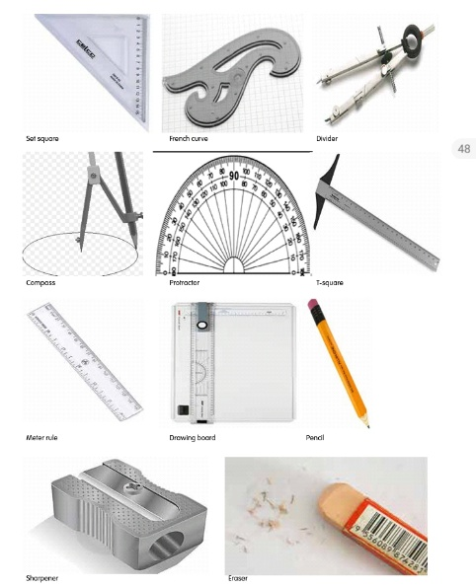 | Drawing instruments
Step 4  Development  (10 minutes) | Group Instructions  List and discuss how to care for drawing instruments. | Groups Activities | Groups work
Step 5  Development  (10 minutes) | Asks each group to present their answers so that you can compare responses with those of other groups. | Presentation | Presentation
Step 5  Conclusion  (5 minutes) | To conclude the lesson, the teacher revises the entire lesson and ask the key questions.  SUMMARY  Drawing instruments are tools used in drawing.  Each drawing instrument is designed for a specific job and it must be properly care for after used. | The learners listen, ask and answer questions.  KEY QUESTIONS – ASSIGNMENT  1. What is drawing?  2. What is a drawing instrument?  3. Name five drawing instruments.  4. Explain how each of the five instruments is used. | Lesson Evaluation and Conclusion

