LESSON DEVELOPMENT TWO

IDENTIFICATION AND USES OF DRAWING INSTRUMENTS

STAGE/TIME | TEACHER’S ACTIVITIES | LEARNER'S ACTIVITIES – MIND/HANDS ON | LEARNING POINTS
Step 1  Introduction  (5 minutes) | INTRODUCTORY ACTIVITIES  Asks pupils to mention different drawing instruments they know. | MIND/HANDS ON ACTIVITIES  Pencils, rulers, color pen, water color, drawing book, cleaner, sharpener, etc. | Linking the Previous knowledge to the new lesson
Step 2  Development  (5 minutes)  Grouping | 1. Groups the learners into four groups – A, B, C, and D.  2. Guide the learners to choose a leader and secretary for your group.  3. Gives each group learning materials. – chart and sample of drawing instruments. | 1. Belong to a group.  2. Choose their leader and secretary.  3. Received learning materials for their group. | Learner’s group, leader and secretary confirmed.
Step 3  Development  (5 minutes) | Lets pupils to carefully study the chart or sample of drawing instruments.  Asks them to describe the use(s) these tools. | 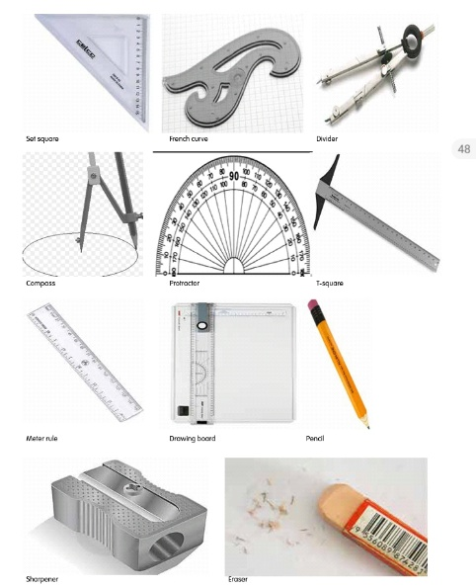 | Drawing instruments
Step 4  Development  (10 minutes) | Group Instructions  Asks each group to use the drawing instruments to draw a large circle with a triangle on top.  Inside the large circle, add smaller circles for eyes, triangle for nose and rectangle for mouth to make a face. | 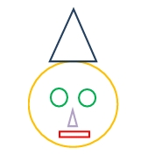  Groups Activities | Groups work
Step 5  Development  (10 minutes) | Asks each group to present their answers so that you can compare responses with those of other groups. | Presentation | Presentation
Step 5  Conclusion  (5 minutes) | To conclude the lesson, the teacher revises the entire lesson and ask the key questions.  SUMMARY – Each drawing instrument is designed for a specific job.  KEY QUESTIONS – ASSIGNMENT  State the use(s) of drawing instruments on the chart.  Each pupil should repeat the activities of the group. | The learners listen, ask and answer questions.  Identification and Uses of Drawing Instruments  Pencil and pen: For making or tracing lines and curves, and for writing labels.  Eraser: For cleaning or rubbing off unwanted parts of a pencil drawing.  Protractor: For drawing accurate angles.  Pairs of compass: For drawing accurate curves, circles and for measuring length.  T-Square: For drawing horizontal lines and for supporting set squares when drawing vertical and inclined lines.  Set Square: For drawing vertical lines and angles 900, 600, 450 and 300.  Ruler: For drawing straight lines and making measurements of length etc.  Pair of dividers: For dividing a straight line into sections of required length and for measuring lengths. | Lesson Evaluation and Conclusion

