LESSON DEVELOPMENT THREE

MEANING OF FORCE – PUSH AND PULL

STAGE/TIME | TEACHER’S ACTIVITIES | LEARNER'S ACTIVITIES – MIND/HANDS ON | LEARNING POINTS
Step 1  Introduction  (5 minutes) | INTRODUCTORY ACTIVITIES  _____ is the force that pulls objects in the air back to the ground.  _____ is the force of attraction.  _____ is the force makes fan to rotate. | MIND/HANDS ON ACTIVITIES  Gravitational force  Magnetic force  Electric force | Linking the Previous knowledge to the new lesson
Step 2  Development  (10 minutes)  Grouping | 1. Groups the learners into four groups – A, B, C, and D.  2. Guide the learners to choose a leader and secretary for your group.  3. Gives each group learning materials – balloon, | 1. Belong to a group.  2. Choose their leader and secretary.  3. Received learning materials for their group. | Learner’s group, leader and secretary confirmed.
Step 3  Development  (5 minutes) | Groups Activities –  Study the chart carefully.  Mention the things which a force can do to an object. | 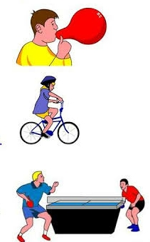 | Effects of forces
Step 4  Development  (10 minutes) | Asks each group to present their answers so that you can compare responses with those of other groups. | Presentation –  1. Force can change the shape of an object.  2. Force can make an object to move faster or slower.  3. Force can make an object to stop. | Presentation
Step 5  Conclusion  (10 minutes) | To conclude the lesson, the teacher revises the entire lesson and ask the key questions.  SUMMARY –  The Effects of Forces can cause the shape of an object to change, to start moving, to stop moving, to accelerate or decelerate.  KEY QUESTIONS –  The Effects of Forces can cause the shape of an object to change (balloon), to start moving, to stop moving, to accelerate or decelerate. Discuss. | The learners listen, ask and answer questions. | Lesson Evaluation and Conclusion

