LESSON DEVELOPMENT TWO

MEANING OF FORCE – PUSH AND PULL

STAGE/TIME | TEACHER’S ACTIVITIES | LEARNER'S ACTIVITIES – MIND/HANDS ON | LEARNING POINTS
Step 1  Introduction  (5 minutes) | INTRODUCTORY ACTIVITIES  Asks pupils to identify the following pictures. | MIND/HANDS ON ACTIVITIES  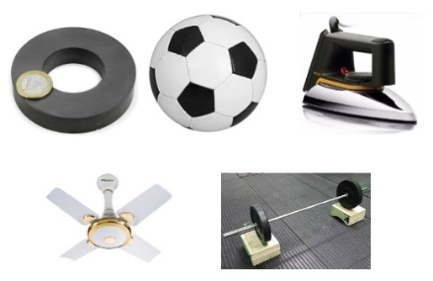 | Linking the Previous knowledge to the new lesson
Step 2  Development  (5 minutes)  Grouping | 1. Groups the learners into four groups – A, B, C, and D.  2. Guide the learners to choose a leader and secretary for your group.  3. Gives each group learning materials – Charts showing different types of forces. Sample of magnetic, ball fan, pressing iron and bucket of water. | 1. Belong to a group.  2. Choose their leader and secretary.  3. Received learning materials for their group. | Learner’s group, leader and secretary confirmed.
Step 3  Development  (10 minutes) | Groups Activities –  1. Use magnet to pick a park of pins and pencil.  2. Throw a ball into the air.  3. What makes a ceiling fan rotate.  4. Lift a bucket of water.  5. Rub your palm against each other. | Explain your observations – expected findings –  1. Magnet attracts iron and magnetic materials.  2. Whatever goes up is bought down.  3. Electricity makes the fan rotate.  4. It is heavy to lift.  5. The palms become warm. | Types of forces
Step 4  Development  (10 minutes) | Asks each group to present their answers so that you can compare responses with those of other groups. | Presentation | Presentation
Step 5  Conclusion  (10 minutes) | To conclude the lesson, the teacher revises the entire lesson and ask the key questions.  SUMMARY –  There are many types of forces – magnetic, gravitational, electric, frictional and muscular force.  KEY QUESTIONS – what happens when you grease your palms before rubbing them together. | The learners listen, ask and answer questions.  The rubbing will be smooth and easy with less force. | Lesson Evaluation and Conclusion

