LESSON DEVELOPMENT ONE

CAPACITY – LITRES AND CENTILITRES

STAGE/TIME | TEACHER’S ACTIVITIES | LEARNER'S ACTIVITIES – MIND/HANDS ON | LEARNING POINTS
Step 1  Introduction  (5 minutes) | INTRODUCTORY ACTIVITIES –  Brings to the class different containers – satchel water, bottle water container, minerals, gallon of different sizes and a bucket of water.  Asks pupils to compare one container with another. | HANDS ON ACTIVITIES  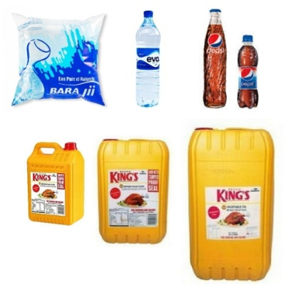  Pupil’s keywords – small, big, size, etc. in comparing. | Linking the Previous knowledge to the new lesson
Step 2  Development  (5 minutes)  Grouping | 1. Groups the learners into four groups – A, B, C, and D.  2. Guide the learners to choose a leader and secretary for your group.  3. Gives each group learning materials – different containers. | 1. Belong to a group.  2. Choose their leader and secretary.  3. Received learning materials for their group. | Learner’s group, leader and secretary confirmed.
Step 3  Development  (5 minutes) | GENERAL ACTIVITIES – INSTRUCTIONS  Asks pupils to check the capacity of each container.  Asks them what are the contents of the containers.  Summary the contents in one word.  Tells them that centilitres (cl) and litres (l) are basic unit for capacity, other include milliliters and kilolitres. | HANDS ON ACTIVITIES  Capacity – 50 cl, 75cl, 150 cl, 1 Litre, 5 Litres, 10 Litres and 25 Litres.  Water, minerals and groundnut/palm oil.  Liquid.  Pupils listen to the teacher’s explanation on basic units of capacity – litres and centilitres. | Units of capacity
Step 4  Development  (10 minutes) | GROUPS ACTIVITIES – INSTRUCTIONS  1. Asks pupils to fill the bigger containers with water using smaller containers.  2. Asks them to describe capacity. | GROUPS WORK | Meaning of capacity
Step 5  Development  (10 minutes) | Asks each group to present their results/solutions so that you can compare responses with those in other groups. | Presentation | Group Presentation
Step 6  Conclusion  (5 minutes) | To conclude the lesson, the teacher revises the entire lesson and ask the key questions.  SUMMARY –  Capacity is the measure of the amount of liquid in a container.  The standard unit of measuring capacity is the litre (L) and centilitre (Cl). | The learners listen, ask and answer questions.  KEY QUESTIONS (ASSIGNMENT) –  Get one litre and one centilitre container, find out how many centilitres of water will fill a litre container | Lesson Evaluation and Conclusion

Reference book – New Method Mathematics Book 4.

