LESSON DEVELOPMENT TWO

CONVERSION INVOLVING LITRES AND CENTILITRES

STAGE/TIME | TEACHER’S ACTIVITIES | LEARNER'S ACTIVITIES – MIND/HANDS ON | LEARNING POINTS
Step 1  Introduction  (5 minutes) | INTRODUCTORY ACTIVITIES –  Asks the pupils to study the chart carefully and tells them to describe the amount of liquid content. | 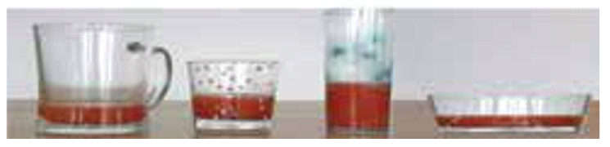  HANDS ON ACTIVITIES | Linking the Previous knowledge to the new lesson
Step 2  Development  (5 minutes)  Grouping | 1. Groups the learners into four groups – A, B, C, and D.  2. Guide the learners to choose a leader and secretary for your group.  3. Gives each group learning materials – different containers and a bucket of water. | 1. Belong to a group.  2. Choose their leader and secretary.  3. Received learning materials for their group. | Learner’s group, leader and secretary confirmed.
Step 3  Development  (5 minutes) | GENERAL ACTIVITIES – INSTRUCTIONS  Gives each group 3 containers of 50 cl and 1 L with a bucket of water – two 50 cl and 1 L.  Lets them fill the 50 cl containers with water, then use the 50 cl container to fill 1 L.  Asks them to observe and make their comments. | HANDS ON ACTIVITIES  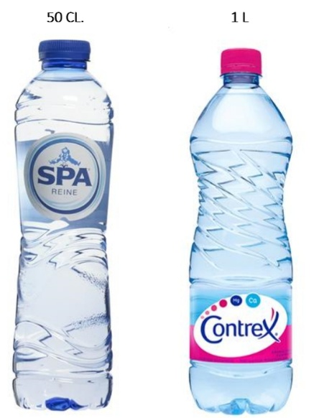  Pupil’s observations and comments – Two 50 cl water filled 1 L  That’s 1 litre = 50 centilitres | Relationship between centilitres and litres
Step 4  Development  (10 minutes) | GROUPS ACTIVITIES – INSTRUCTIONS  Convert  1. 7 L to cl  2. 6.5 L to cl  3. 500 cl to l  4. 650 cl to l | GROUPS WORK  Note for the pupils – When converting higher capacity measure to a smaller capacity - From to l to cl, multiply by 100. And divide by 100 when from cl and l. | Conversion of litres and centilitres
Step 5  Development  (10 minutes) | Asks each group to present their results/solutions so that you can compare responses with those in other groups. | Presentation | Group Presentation
Step 6  Conclusion  (5 minutes) | To conclude the lesson, the teacher revises the entire lesson and ask the key questions.  SUMMARY –  Capacity is the measure of the amount of liquid in a container.  The relationship between litre and centilitre, that’s 1 litre = 10 cl. | The learners listen, ask and answer questions.  KEY QUESTIONS (ASSIGNMENT) –  Copy and complete the table  S/n Litre Centilitre  1 100  0.01 1  3  3.5  65 | Lesson Evaluation and Conclusion

Reference book – New Method Mathematics Book 4.

