LESSON DEVELOPMENT ONE

PLANE SHAPES – A CIRCLE
CIRCUMFERENCE, DIAMETER AND RADIUS

STAGE/TIME | TEACHER’S ACTIVITIES | LEARNER'S ACTIVITIES – MIND/HANDS ON | LEARNING POINTS
Step 1  Introduction  (5 minutes) | INTRODUCTORY ACTIVITIES –  Asks the pupils to draw and describe a circle. | HANDS ON ACTIVITIES  Pupil’s keyword in describing a circle is ROUND. | Linking the Previous knowledge to the new lesson
Step 2  Development  (5 minutes)  Grouping | 1. Groups the learners into four groups – A, B, C, and D.  2. Guide the learners to choose a leader and secretary for your group.  3. Gives each group learning materials – cardboard, scissor and drawing materials. | 1. Belong to a group.  2. Choose their leader and secretary.  3. Received learning materials for their group. | Learner’s group, leader and secretary confirmed.
Step 3  Development  (5 minutes) | GENERAL ACTIVITIES – INSTRUCTIONS  1. Draw 2 circles on a cardboard.  2. Cut out the 2 circles.  3. Fold and cut one circles into two equal parts and draw a line to divide the second circle.  4. Fold and cut one of the semi circles.  5. Trace the line on the second circle not cut.  6. Compare your results with this chart. | 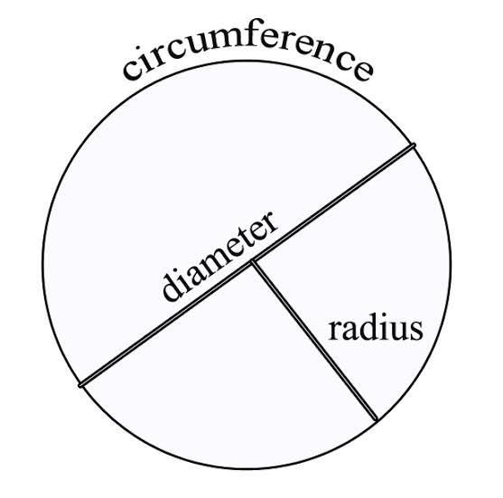  HANDS ON ACTIVITIES | Part of circle – circle, diameter and radius.
Step 4  Development  (10 minutes) | GROUPS ACTIVITIES – INSTRUCTIONS  1. Describe the following – circumference, diameter and radius.  2. State the similarities and different between diameter and radius. | GROUPS WORK  Circumference of a circle is the distance around it.  Diameter is the line which divide the circle into 2 equal parts.  Radius divide the diameter into 2 equal parts. | Identification of circumference, diameter and radius.
Step 5  Development  (10 minutes) | Asks each group to present their results/solutions so that you can compare responses with those in other groups. | Presentation | Group Presentation
Step 6  Conclusion  (5 minutes) | To conclude the lesson, the teacher revises the entire lesson and ask the key questions.  SUMMARY – A circle is a simple closed round shape. The circumference of a circle is the distance around a circle. Diameter is line which passes through the centre of a circle. It divides the circle into 2 equal parts. Radius is a straight line from the centre of a circle to the circumference. It is half of diameter. | The learners listen, ask and answer questions. | Lesson Evaluation and Conclusion

Reference book – New Method Mathematics Book 5.

