LESSON DEVELOPMENT TWO

PLANE SHAPES – A CIRCLE
CHORD, MINOR AND MAJOR SEGMENT

STAGE/TIME | TEACHER’S ACTIVITIES | LEARNER'S ACTIVITIES – MIND/HANDS ON | LEARNING POINTS
Step 1  Introduction  (5 minutes) | INTRODUCTORY ACTIVITIES –  Asks the pupils to draw with a diameter and radius. | 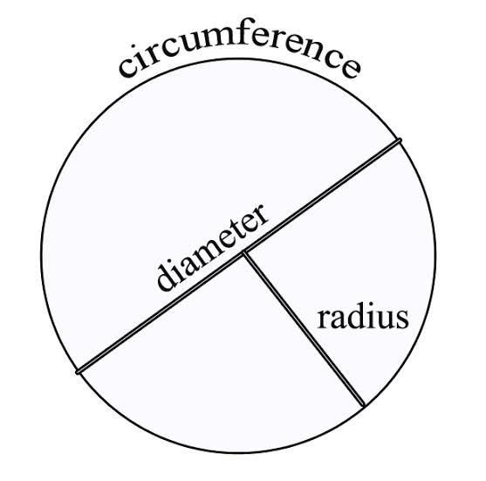  HANDS ON ACTIVITIES | Linking the Previous knowledge to the new lesson
Step 2  Development  (5 minutes)  Grouping | 1. Groups the learners into four groups – A, B, C, and D.  2. Guide the learners to choose a leader and secretary for your group.  3. Gives each group learning materials – cardboard, scissor and drawing materials. | 1. Belong to a group.  2. Choose their leader and secretary.  3. Received learning materials for their group. | Learner’s group, leader and secretary confirmed.
Step 3  Development  (5 minutes) | GENERAL ACTIVITIES – INSTRUCTIONS  1. Draw 2 circles on a cardboard.  2. Cut out the 2 circles.  3. Fold and cut one circles into two (not equal parts).  4. Trace the line on the second circle not cut.  5. Compare your results with this chart. | HANDS ON ACTIVITIES  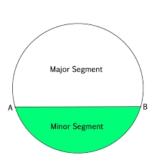  Note for the pupils – The line on the circle is called a chord or line of segment. | Part of circle – a chord and segment (minor and major)
Step 4  Development  (10 minutes) | GROUPS ACTIVITIES – INSTRUCTIONS  1. Differentiate between diameter and chord.  2. Differentiate between minor and major segment. | GROUPS WORK  Diameter divides a circle into 2 equal parts while a chord also divide a circle but not into equal parts.  2. The different between minor and major segment – minor segment is the small part of the circle divided by chord while major segment is the large part of the circle after the small one. | Identification of chord and segment.
Step 5  Development  (10 minutes) | Asks each group to present their results/solutions so that you can compare responses with those in other groups. | Presentation | Group Presentation
Step 6  Conclusion  (5 minutes) | To conclude the lesson, the teacher revises the entire lesson and ask the key questions.  SUMMARY – A chord is a line segment joining two points on the circumference.  Minor and major segment are both parts of the circle divided by a chord. | The learners listen, ask and answer questions. | Lesson Evaluation and Conclusion

Reference book – New Method Mathematics Book 5.

